
Phi Alpha Kappa
Newsreel
Fall 2016 Issue

A tradition of Phi Alpha Kappa Christian Fraternity since 1934

Presidential Greetings

Dearest Alumni and Friends of Phi Alpha Kappa,

Greetings from the Active Chapter here in Ann Arbor! We are now into the heart of the school year and members and pledges alike are busy studying for finals, looking forward to Christmas break.

The fraternity is off to a great start, although our numbers are not quite as high as they have been in the past. We currently have 17 actives and 5 pledges, but we are employing some new strategies in recruiting in hopes of becoming better known on campus. As we look to continue to be a light at Michigan and in Ann Arbor, I ask that if you know of anyone who is looking for a place to live among Christian men at the University of Michigan, tell them about the great fraternity that is Phi Alpha Kappa. We hope that through our extensive alumni breadth and outreach on campus we can attract Christian men of character to join our brotherhood, and carry on the traditions of the Dutch House for years to come.

I want to thank all of the alumni who were able to make it out to Alumni Day a few weeks ago. It was great to fellowship together over food, enjoying each others company bridged by stories of time spent in Ann Arbor and with brothers of Phi Alpha Kappa. We are greatly blessed and appreciative of such supportive alumni. We especially thank the Alumni Board for their continued effort and improvement of the Dutch House and the members inhabiting it. We truly appreciate your prayer, encouragement and guidance.

As a whole, things are going very well at Phi Alpha Kappa. Our brotherhood is beginning to develop roots with the pledges, and is growing even deeper amongst actives. As we look to shine for God’s kingdom on campus, we ask for your continued prayers for deepening intimacy with the Father, and also between brothers.

God bless,

Nate Woznick
Active Chapter President
pres@phialphakappa.com

Table of Contents

In this Issue:

Announcements 3
A Word about our Website 3
Phi Alpha Kappa's Annual Spring Event: "The Smoker" 3
Phi Alpha Kappa Pint Glasses 4
In Memoriam 4
Officer Reports 5
Vice President Report 5
Business Manager Report 6
Sergeant-At-Arms Report 6
Steward Report 6
Social Chairman Report 6
Pledge Chairmen Report 7
Athletic Chairman Report 7
Historian Report 7
Beastmaster Report 7
Chaplain Report 8
Charity Chairman Report 8
Meet the Pledges 9
Daniel Botting by Jonathan Timma 9
Josh Fagerlin by Zack Felker 9
Daniel Ridderbos by Jacob Molewyk 10
Joseph Wang by Curt Silverthorn 10
Danny Yucra by Joe TenBroek 11
The Active Members 12
The Pledges 14

Announcements

A Word about our Website

Please, visit our website! This is a great way to stay up to date on the current happenings and fraternity activities. It’s also a great tool for recruiting new members. Updates are coming soon.

If you know of any young men who might be interested in Phi Alpha Kappa, please share our website with them!
www.phialphakappa.com

Phi Alpha Kappa’s Annual Spring Event: “The Smoker”

What: As we have done the last few years now, The Smoker will be a casual, open house style event in which past, present and future Phi Alpha Kappa brothers will be able to enjoy food and drinks at Founder’s Brewing Company while watching the Michigan-Illinois basketball game. Spouses and dates are welcome to join us, hors d’oeuvres and soda will be provided for all who attend, and there will be a cash bar. Alumni and Active members alike are encouraged to invite graduating high school seniors and their parents or anyone else who may be interested in membership. Our Vice President, Curt Silverthorn, will give a brief presentation covering some history of Phi Alpha Kappa and our current house atmosphere. If you know any students who may be interested in attending The Smoker this year, please contact Curt at vp@phialphakappa.com.

Where: Founder’s Brewing Company Centennial Room
235 Grandville Ave SW
Grand Rapids, MI 49503

**Free parking is available in the Founder’s lot located directly behind the brewery (to the South). The Centennial Room is accessed by using the elevator in the company store.

When: Saturday, January 21st, 2017
Beginning at 2:00PM until 5:00PM

Please remember to RSPV to Dave Slopsema at dslops@yahoo.com

Phi Alpha Kappa Pint Glasses

As we have previously mentioned in an earlier Newsreel editions, the active chapter has been looking into ordering custom pint glasses. Our very own Alex Harris has followed through on this venture, and we are making these glasses available to alumni. The glasses will cost $10 each, plus shipping and handling needed to send the glass to you (if you can make arrangements to pick it up from the house it will be a flat $10). Pictures can be seen below:
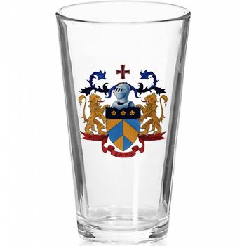
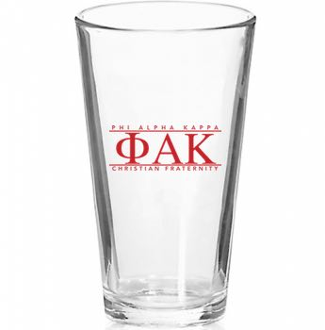

(front) (back)

The first batch has just come in to Ann Arbor and they’re really sharp. We are not limiting the amount of glasses that can be purchased.

For anyone interested in purchasing a pint glass, email Nate Woznick at pres@phialphakappa.com

In Memoriam

We have been informed of the loss of two of our alumni: Carl Van Appledorn MD and Ivan Boerman DDS.

We express our condolences to each their loved ones.

Officer Reports

Vice President Report

Our current pledge class includes 5 members. Two freshmen, one junior transfer student, one senior and one first year graduate student. We also have one sophomore who is slated to start his pledge process in January 2017, and thus will be a lame duck. Recruiting efforts thus far have included, Northfest, Festifall, bus signs, flyers on campus boards, and co-hosting a beginning of the year cookout with SAO, the Christian sorority. We are hoping to reap the rewards of some of these recruiting events and bring in a few more lame duck pledges to add to the pledge class. Because of graduating a very large class last year we are down to 18 actives in addition to our 5 pledges. The house has remained full through boarders, of which there are currently 6. We hope that through a large lame duck group, and large pledge class for next year. we will need less boarders in the future. To help with this, we encourage you to prompt anyone who is attending Michigan or potentially applying to Michigan to check us out! Word of mouth has always been our most effective recruitment tool and our large alumni base has brought us many pledges in the past.

Curt Silverthorn, Vice President
vp@phialphakappa.com

Business Manager Report

My name is Taylor Buist and this is my first year as Business Manager of Phi Alpha Kappa. The house has a small pledge class this year which was worrisome in the weeks leading up to the fall semester. We are looking to make sure our next pledge class provides additional financial security. Currently, we have 18 actives and 5 pledges, and 6 boarders. Our goal in the house is to maintain a reasonable and responsible Kitchen and Operations budget while our membership recovers.

Taylor Buist, Business Manager
business@phialphakappa.com

Sergeant-At-Arms Report

This year has been off to a great start. We had a city housing inspection earlier in the year that uncovered quite a few issues. Through collaboration between the active chapter and alumni, all of the issues have been resolved. Work day was a resounding success. The actives put in a great day of work, completing numerous small tasks as well as cleaning the attic and repainting the driveway. As we move into the winter, we are making plans to better insulate the great room and keep the driveway clear.

Will Perrry, Sergeant-at-Arms
sergeant@phialphakappa.com

Steward Report

My name is Jonathan Timma and I am the steward for the 2016-2017 academic year. Everything is well with the kitchen and we are thankful and blessed to have our chef Amy cooking food for us again this year. The food she has provided has been great. Great conversations are always occurring at lunch and dinner and we are all happy to be able to share meals with each other as brothers in Christ.

Jonathan Timma, Steward
steward@phialphakappa.com

Social Chairman Report

This fall has been a great one for the men of PAK! On top of having the privilege of watching Michigan start the season 8-0, we’ve had a number of social events! In September, we had a fall cookout with the Christian Sorority SAO. This doubled as a hangout event between the 2 houses, and a recruitment event for us as well! Great weather and a solid turnout made it an awesome event! In mid-October, we traveled as a house to a Halloweekend at Cedar Point, and had a great night of coasters and haunted houses! Alumni day was a success this year, held on the homecoming game. At the end of October, we had our annual Halloween party at the house, co-hosted with SAO. We had a fire, music, dancing, yard games, and a costume contest! Well over 100 people attended, and we received great feedback on the party! A pizza viewing party was held the next day for the Michigan vs Michigan State football game! In November, we plan to have a guys night out for dinner, and a trip to skyzone! The annual Christmas party will be held in December, along with an additional guy's night out if funds allow!

Garrett Prost, Social Chairman
social@phialphakappa.com

Pledge Chairmen Report

PAK has been blessed with 4 new pledges this fall: 1 graduate student, 1 senior, 1 junior, and 1 freshman. All have acclimated well to life in the house and the actives are looking forward to getting to know them better over this school year. We’re grateful for the opportunity to walk with them on the path toward active membership.

Taylor Buist & Daniel Harris
Pledge Chairmen

Athletic Chairman Report

Sports have continued to be an excellent medium for growing bonds between brothers here at Phi Alpha Kappa. Our athletic prowess is not always the strongest, but our teamwork and sportsmanship are unmatched by any other team. A potential run in the soccer playoffs was brutally cut off by a round of midterms, but our sights have been set ahead on the upcoming season of flag football and broomball. It has been a great joy to watch pledges and actives come together and discover new things about each other, and build ties that carry over into regular house life.

Joel Harkema, Athletic Chairman

Historian Report

History continues to unfold here at the Dutch House, and I am doing what I can to ensure that highlights will be preserved for those who follow. Progress is being made on electronically archiving important data. Plans are in the works to archive the most important of our documents at the Bentley Historical Library in perpetuity, where they will be forever safe and accessible to future brothers. Great care is being taken to withhold fraternal secrets from the public archive during this process. Progress is slow going on all fronts, but time is not of real importance.

May the peace of Christ find you all. Go Blue.

Zack Felker, Historian
historian@phialphakappa.com

Beastmaster Report

We still have Riley as our house dog, and he is as wonderful and energetic as ever. Riley turned 5 years old over this past summer, which, in dog years, means he would be old enough to run for President of the United States. However, he turned down the position, preferring instead to go on walks around campus, chase squirrels, and get lots of attention from everyone he meets, which is an indisputably more fulfilling choice. As such, we keep Riley around the house, and he brings love and affection to all of our members.

Joe Sorenson
Beastmaster

Chaplain Report

This year, I am the Chaplain for Phi Alpha Kappa. Because the PAK Packs Nate Woznick (the previous Chaplain) started last year were very helpful for the house and made a big difference, I decided to continue them and they are going very well! Most of the PAK Packs are guys-only, but one of them is co-ed and includes several members from SAO Christian Sorority.

In addition, Matt Ackerman, a pastor from Campus Chapel, comes by on Monday nights to lead a men’s Bible study, going through a book called “Man Enough: How Jesus Redefines Manhood” by Nate Pyle. We also continue Praise and Worship on Wednesday nights, and plan to have monthly joint worship nights with SAO. I believe the house is really going in a good direction, but because nobody is perfect, we still have room for improvement. Please continue to pray for PAK to seek God’s direction in how we interact with each other and with people outside our fraternity, and that we will gain more godly men as pledges, and strengthen our relationships with BYX (the other Christian fraternity on campus), SAO (the Christian sorority on campus), and other Christian organizations on the campus. Thank you!

Jacob Molewyk
Chaplain

Charity Chairman Report

As Charity Chair, I have continued to manage Phi Alpha Kappa's involvement in the homeless ministry through Vineyard Church of Ann Arbor. Sigma Alpha Omega, our sister Christian sorority, has continued their involvement as well. This ministry is focused on providing food, clothing, and resources to those of Ann Arbor who are impoverished. Items are handed out on Friday nights at Liberty Park Plaza, and on Thursday nights we prepare bags to hand out. Most recently the Vineyard Homeless held a Thanksgiving lunch for people who could not afford one or did not have family to share one with. This event saw over 100 people served that day.

In late March we will have our annual Casino Night, where we raise money to be donated to various charitable organizations. Casino Night has consistently raised substantial sums of money each year and we plan to continue this strong tradition.

Micah Harris
Charity Chairman

Meet the Pledges

Big brothers write these articles about their little brothers.

Daniel Botting by Jonathan Timma

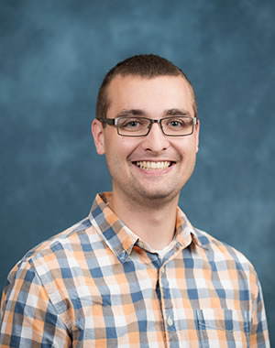
The crème of the crop, Daniel Botting is the oldest pledge this fall and is a grad student in the Ford School of Public Policy. He is originally from Muskegon, Michigan, but has spent the last six years in Grand Rapids. Daniel completed his undergraduate degree at Calvin College (2014) in Grand Rapids where he majored in finance and economics, and a minor in math. Prior to his acceptance into grad school, he worked at Steelcase in Grand Rapids working in finance. His career goal is to conduct research and advise policy makers. Given the unusually high number of brothers having some variation of the name Daniel, we have elected to call him “D Bot”. Like his big brother, he is a huge fan of Michigan football and college football as a whole. There haven’t been many Saturdays this semester where we haven’t watched a non-Michigan football game together. He also enjoys playing video games. Call of Duty and Smash are some of his favorites. I am honored to call him my little brother. I look forward to getting to know D Bot over the next several months and can’t wait to see him be the leader of this pledge class.

Josh Fagerlin by Zack Felker
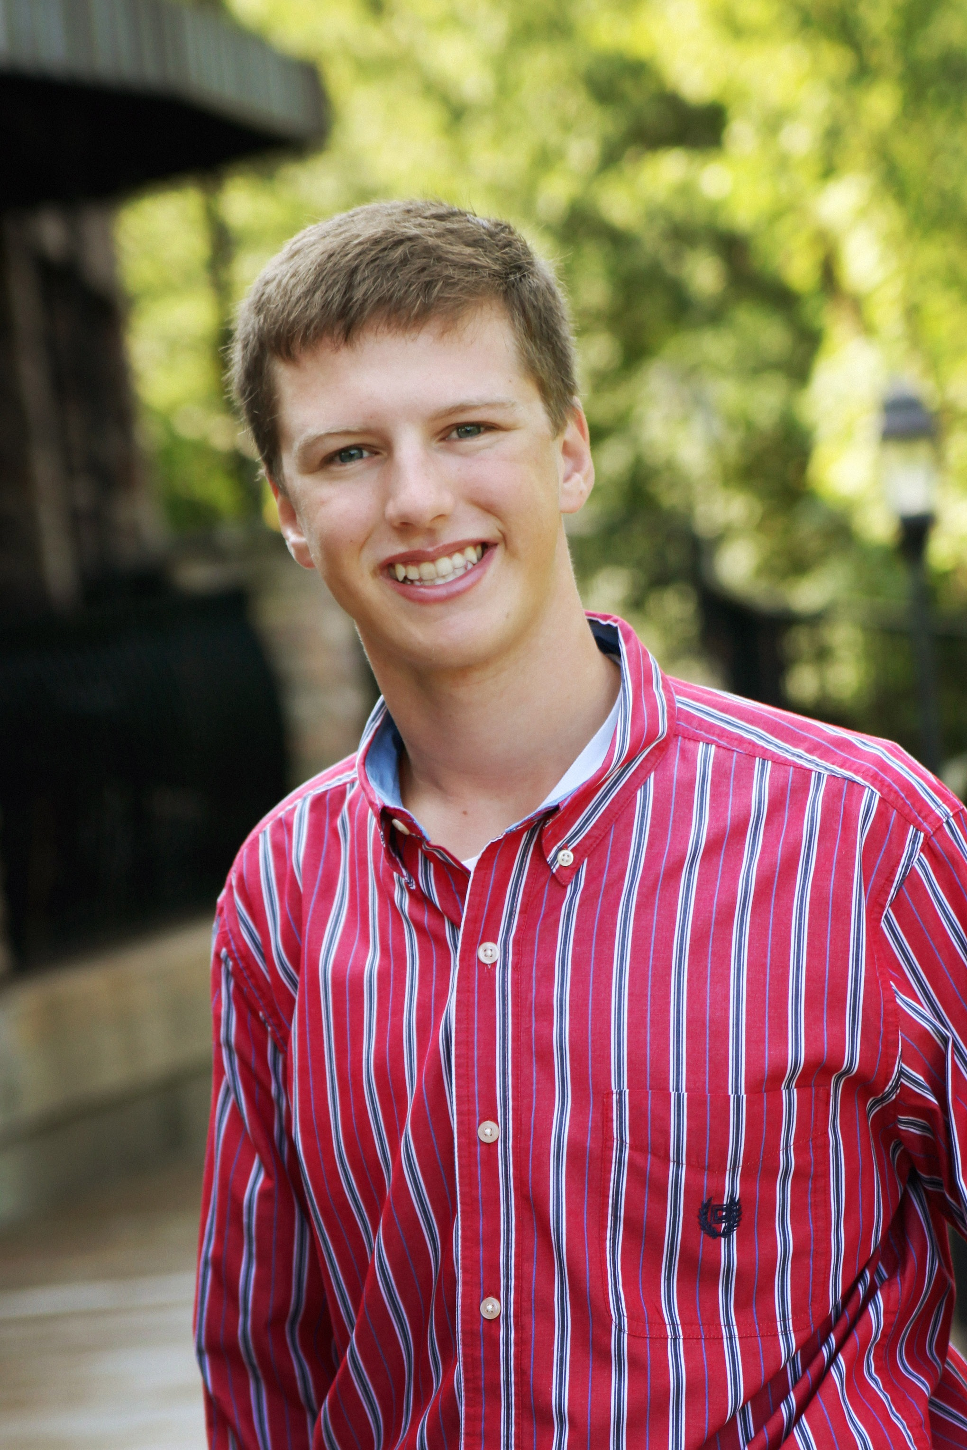
Josh is a freshman in the College of Engineering, where he intends to pursue a degree in Aerospace Engineering. He hopes to use his degree to “build rockets and stuff”. Josh comes to us from Rockford High School, where he played in the marching band for four years. He has since joined our very own University of Michigan Marching Band. Josh spends his Sunday mornings playing flag football in a local league. With his mornings occupied, he most often attends an evening Mass at St. Mary's Student Parish, where he is undergoing the process to become Catholic.

Daniel Ridderbos by Jacob Molewyk
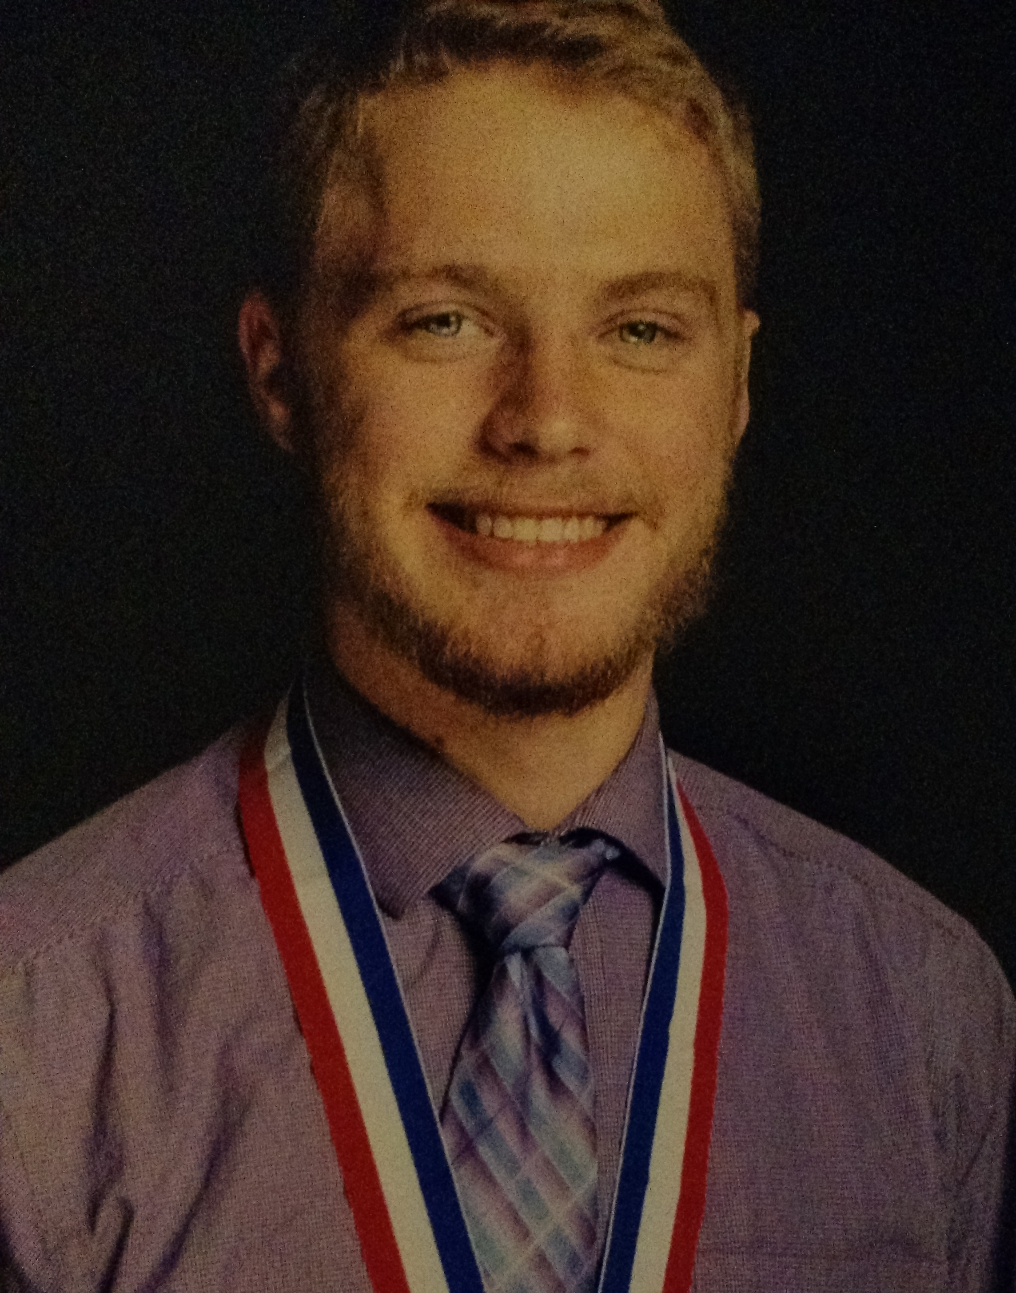
Dan Ridderbos was born in Grand Rapids, Michigan and grew up in Middleville, Michigan. He is currently a junior majoring in civil engineering and transferred this year from Grand Rapids Community College. He was homeschooled throughout his entire childhood and growing up, enjoyed playing with Legos, lightsabers, riding a wagon down the hill, and playing soldiers and building forts in the woods with his friends. These days, in his leisure time, Dan enjoys reading, singing, playing soccer and football, and watching hockey. He is planning on starting a University of Michigan chapter of Ratio Christi, an international Christian apologetics organization that helps Christians logically defend their faith. In terms of student organizations, Dan is currently a member of the Steel Bridge Team and the American Society of Civil Engineers. He potentially wants to use his civil engineering skills in the mission field someday, to improve geotechnical infrastructure in third world countries.

Joseph Wang by Curt Silverthorn
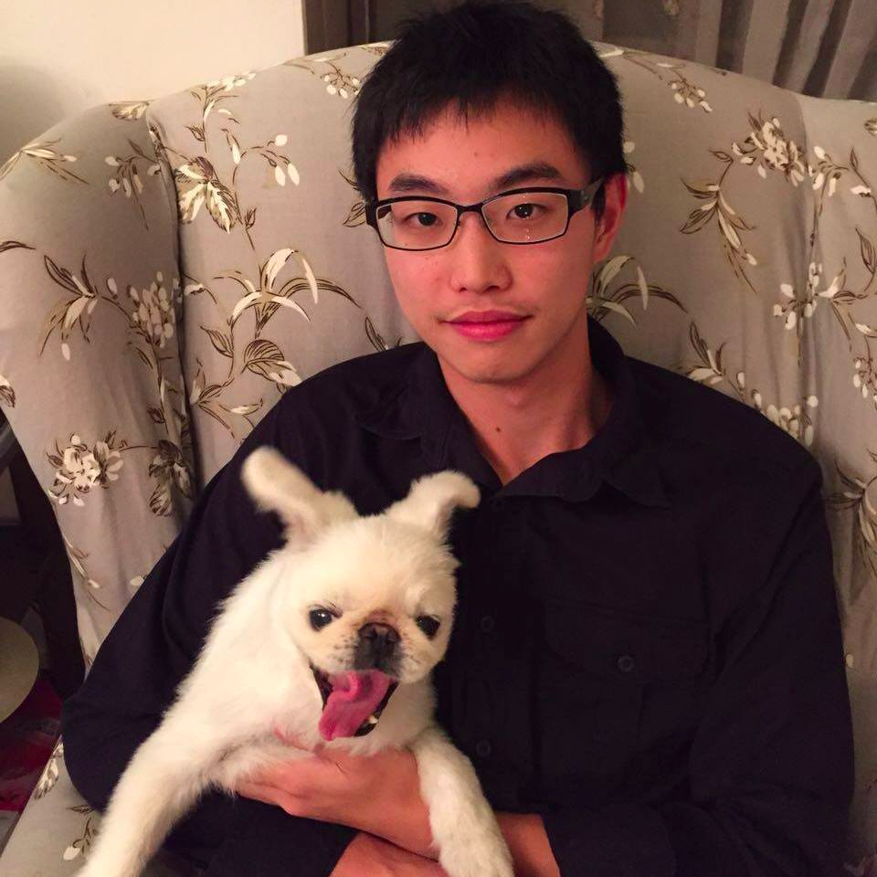
Joseph Wang comes to the Dutch House all the way from Taipei, Taiwan. He is a first year undergraduate student here at the University of Michigan and he is planning on going to medical school. Joseph is very excited to join the fraternity, and experience more of the American culture, and we are very happy to have him! Outside of Phi Alpha Kappa Joseph is part of Soulwell a life group of harvest community church. His hobbies include playing league of legends, a favorite video game in the house, and running.

Danny Yucra by Joe TenBroek
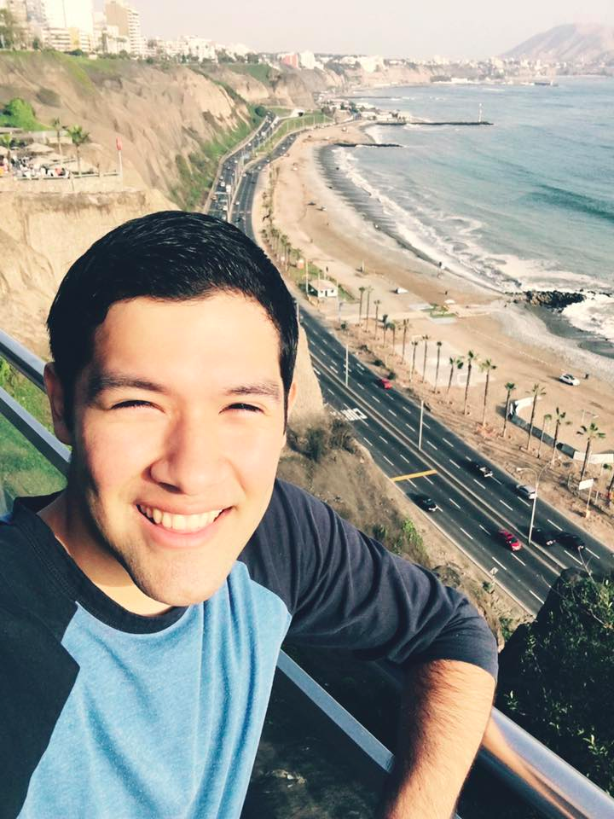
This is Danny Yucra: a talented musician, avid league of legends player, and a huge football fan. He is from the warm and happening city of Miami, Florida, where he graduated from Coral Reef Senior High School in 2012. He then decided to come to the freezing, beach-less state of Michigan, where he is currently a fifth-year senior at the University of Michigan studying Cello Performance. If he’s not practicing musical pieces in the School of Music, you can find him hanging with people in the house, winning every league of legends game, watching his favorite TV shows, or watching football games in the Great Room. Overall, Danny is a great addition to the house and we all hope to get to know him more over the school year.

The Active Members

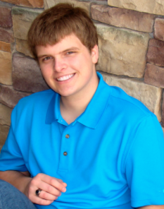 | Zack Felker  Historian  Junior  Physics, Astronomy |  | 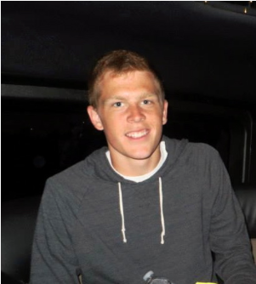 | Lucas Barnes  Senior  Mechanical Engineering
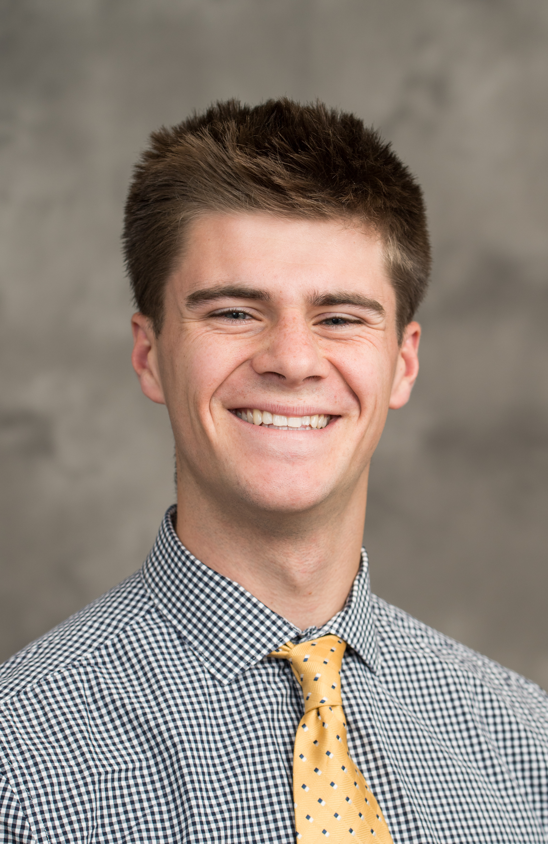 | Nate Woznick  President  Junior  Mechanical Engineering |  | 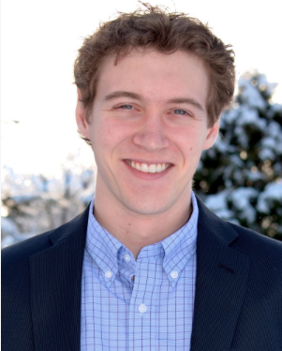 | Alex Harris  4rd year medical student  Medical School
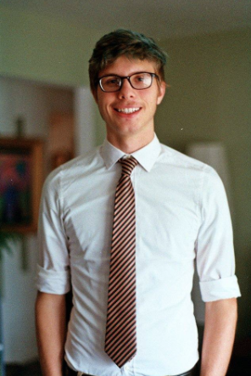 | Tate Mazer  Junior  Computer Engineering |  | 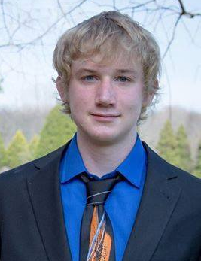 | Joel Harkema  Athletic Chair  Sophomore  Civil Engineering
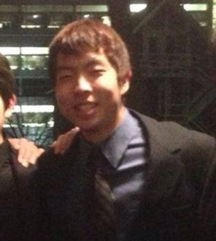 | Joe TenBroek  Senior  Mechanical Engineering |  | 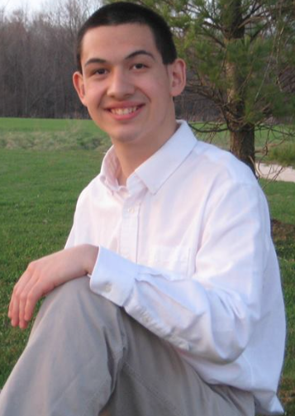 | Jacob Molewyk  Chaplain  Junior  Civil Engineering
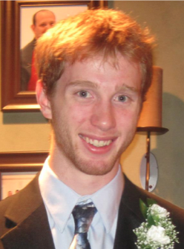 | Alari Maricq  Senior  Aerospace Engineering |  | 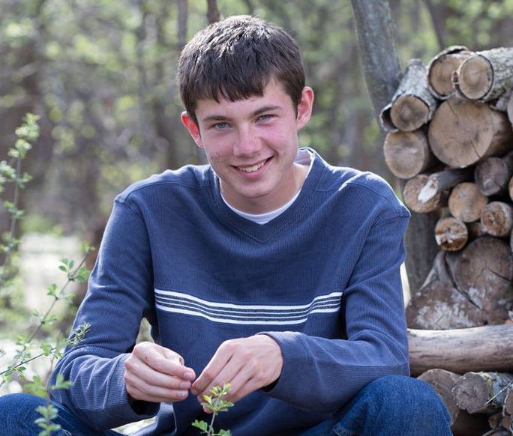 | Will Perry  Sergeant, Webmaster  Sophomore  Aerospace Engineering
 | Joe Sorenson  Beastmaster  Senior  Computer Science |  | 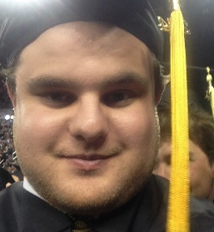 | Jonathan Timma  Steward  Master’s Student  School of Information
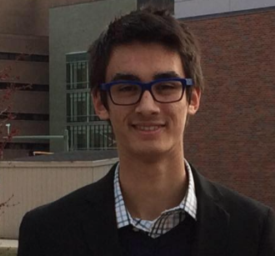 | Daniel Harris  Pledge Chairman  Sophomore  Microbiology |  | 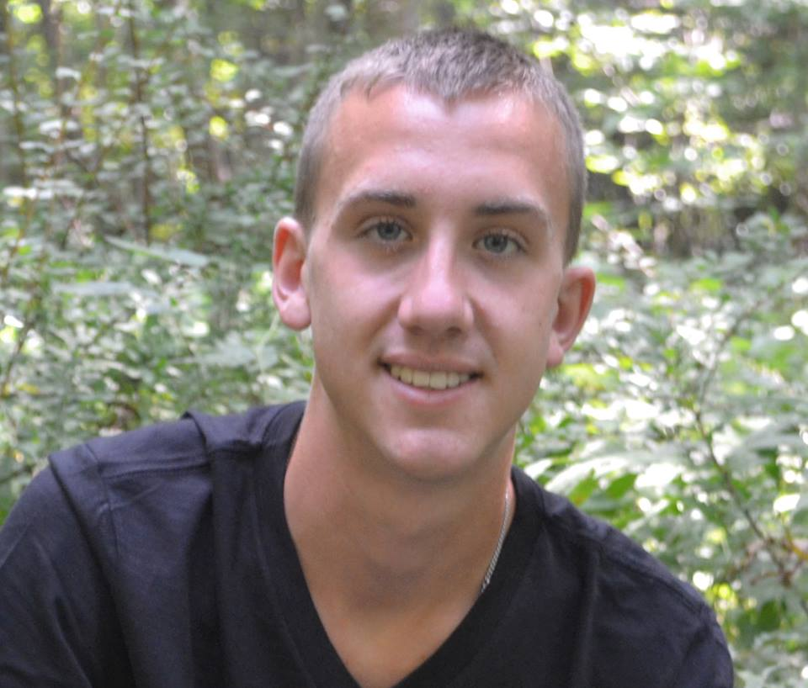 | Curt Silverthorn  Vice President  Junior  Computer Science
 | Hayden Youngs  Secretary  Senior  Mechanical Engineering |  | 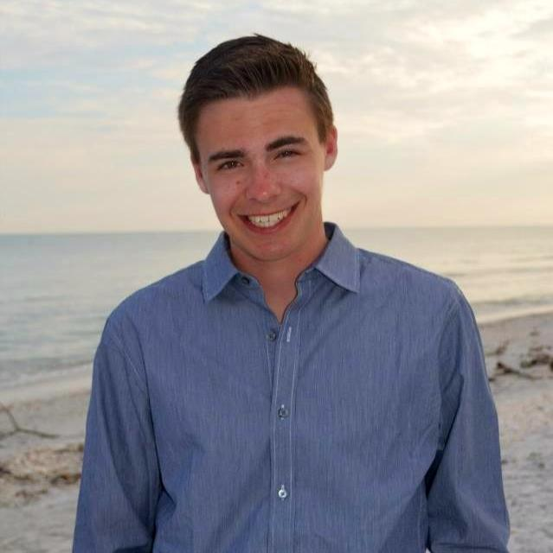 | Garrett Prost  Social Chairman  Junior  Industrial and Operations Engineering
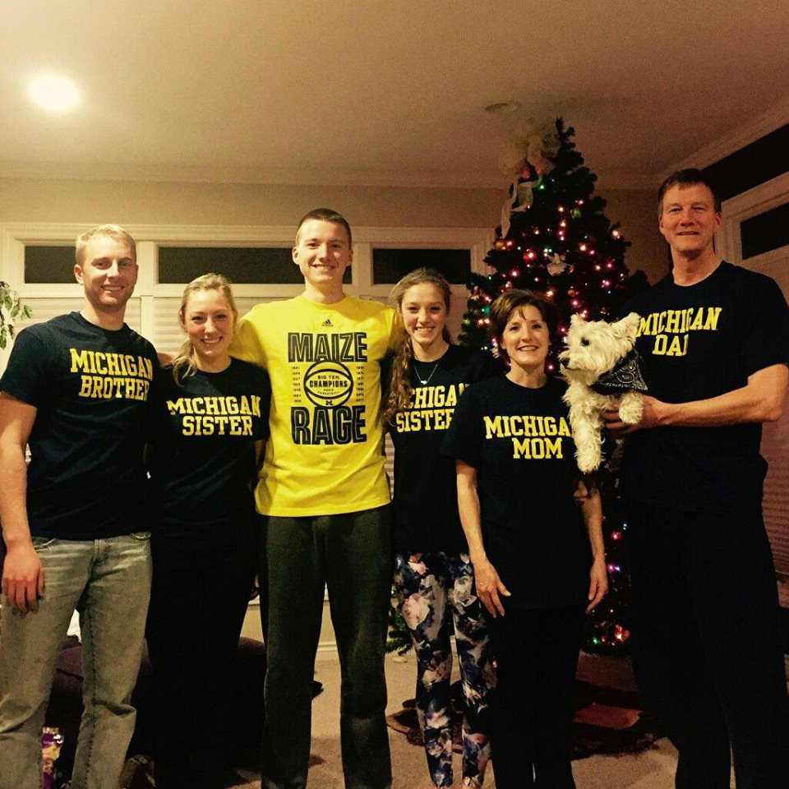 | Taylor Buist  Business Manager, Pledge Chairman  Junior  Computer Science |  |  | Andrew Dykstra  Senior  Environmental Engineering

The Pledges

 | Daniel Botting  Master’s Student  Public Policy |  | Josh Fagerlin  Freshman  Aerospace Engineering
 | Daniel Ridderbos  Junior  Civil Engineering |  | Joseph Wang  Freshman  Pre-Med
Danny Yucra
Senior
Cello Performance

