
Phi Alpha Kappa
Newsreel
Fall 2015 Issue

A tradition of Phi Alpha Kappa Christian Fraternity since 1934

Presidential Greetings

Dearest Alumni and Friends of Phi Alpha Kappa,

Warm greetings from the active chapter in Ann Arbor, where we have begun to hear the crunch of leaves underfoot. The semester is in full swing and our members are busy studying for midterms and fervently looking forward to Thanksgiving break.

The fraternity is doing well this year, and we beginning to recover from a few years of low membership. We currently only have 15 actives, but we are encouraged by the fact that our recruitment over the last year has manifested itself in a good-sized pledge class of eleven; up from last year’s class of eight. It truly In the hopes of continuing to be a light at Michigan and in Ann Arbor, I ask that if you know of anyone who is looking for a place to live among Christian men at the University of Michigan, tell them about the great fraternity that is Phi Alpha Kappa. We hope that through this we can attract Christian men of character to join our brotherhood, and carry on the traditions of the Dutch House for years to come.

I would like to thank all of the alumni who were able to join us for Alumni Day year. It was great to eat, converse, and reminisce with you about your time spent in Ann Arbor and at the fraternity. Phi Alpha Kappa is very blessed to have the prayers and support of such an outstanding alumni network. Special thanks go out to the Alumni Board for the time and effort that they constantly give the Dutch House. We truly appreciate your support, encouragement, and guidance.

Overall, things are going well at Phi Alpha Kappa. Although membership is a little down, our brotherhood is still strong. We ask that you continue to keep Phi Alpha Kappa and its members in your prayers, as we seek out Christ in our own lives, and strive to bring his love and mercy to the rest of the University of Michigan.

God bless you all,

John Swets
Active Chapter President
pres@phialphakappa.com

Table of Contents

In this Issue:

Presidential Greetings 1
Announcements 4
A Word about our Website 4
The Phi Alpha Kappa Annual Spring Event – “The Smoker” 4
Officer Reports 5
Vice President Report 5
Business Manager Report 6
Sergeant-At-Arms Report 6
Steward Report 6
Social Chairman Report 6
Pledge Chairmen Report 7
Athletic Chairman Report 7
Historian Report 7
Beastmaster Report 8
Chaplain Report 9
Charity Chairman Report 9
Meet the Pledges 10
Joel Harkema by Zack Felker 10
Jim LeFebre by Jared Elenbaas 10
Garrett Prost by Alex Harris 10
Will Perry by Nate Woznick 11
Jonathan Timma by Hayden Youngs 11
Michael Nykamp by Joe Sorenson 11
Daniel Harris by Tate Mazer 12
Ryan Olthoff by John Swets 12
Taylor Buist by Alari Maricq 12
Curt Silverthorn by Ryan Wawrzaszek 13
Micah Harris by Lucas Barnes 13
The Active Members 14

Announcements

A Word about our Website

Please, visit our website! This is a great way to stay up to date on the current happenings and fraternity activities. It’s also a great tool for recruiting new members. Updates are coming soon.

If you know of any young men who might be interested in Phi Alpha Kappa, please share our website with them!

www.phialphakappa.com

The Phi Alpha Kappa Annual Spring Event – “The Smoker”

What: Similar to last year, the event will be more conducive to an open, social, less formal atmosphere with the opportunity to become acquainted with the current Active Chapter, other alumni, and prospective pledges while watching the Michigan-Nebraska basketball game. Spouses and dates are welcome, and food and pop will be provided for all who attend. Alumni are encouraged to invite graduating high school seniors and their parents or others that may be interested in membership. Additionally, prospective members will get the opportunity to meet the actives, alumni, and get a better understanding of what Phi Alpha Kappa is all about. If you know any students who may be interested in attending The Smoker this year, please contact the Vice President, Hayden Youngs, at vp@phialphakappa.com.

Where: Founders Brewing Company Centennial Room
235 Grandville Ave SW
Grand Rapids, MI 49503

There is free parking in the Founders lot directly behind the brewery. The Centennial Room can be accessed by using the elevator in the Company Store.

When: Saturday, January 23 2016
Beginning at 2:00 pm

Please remember to RSVP to Dave Slopsema at dslopsema@yahoo.com

Officer Reports

Vice President Report

Spring and summer recruiting resulted in nine new pledges to go along with our four “lame duck” pledges from last year. Of the incoming class the numbers included four freshmen, a junior transfer student, three graduate students, and an intern at the University of Michigan Health System hospital. Unfortunately, one of the freshmen, which was an out-of-house pledge, decided to de-pledge. For recruiting efforts, we decided not to do Festifall this year due to lack of success in recent years. However, for future years we may want to consider doing Escapade because it targets incoming freshmen during welcome week. Furthermore, we are hosting our annual Halloween party in which we plan to reach an attendance of over 200 people; hopefully there is the potential to produce some prospective pledges from this event.

We currently have three boarders in the house, which is relatively low in respect to recent years. However, with attrition due to graduation of some of our members, in addition to upcoming marriages, we need to have another larger-than-normal pledge class for 2016-2017 in order to keep our membership numbers high. So, we encourage you to prompt anyone who is attending Michigan or potentially applying to Michigan to check us out!

Hayden Youngs, Vice President
vp@phialphakappa.com

Business Manager Report

This is my third year as Business Manager at Phi Alpha Kappa, and the house remains in good financial shape. We are one resident under capacity this semester, with 15 actives, 11 pledges, and 4 boarders living in the house. I am in the process of resolving a few long-running issues with the IRS relating to forms that were misfiled in the year before we hired Rose Grand as our CPA. Rose has been very helpful throughout this process, and I anticipate the issue being closed shortly. Kitchen and Operations budgets are consistent with past years, and the social budget is being used efficiently, so we should remain in good financial standing all year. By cutting down on unnecessary spending and focusing on repairs and improvements to the house, we will improve life in the house while maintaining a reasonable budget.

Ryan Wawrzaszek, Business Manager
business@phialphakappa.com

Sergeant-At-Arms Report

The year is off to a good start. House jobs have been going well, and work day was a success. Actives were ready and willing to help where they could, and the house definitely grew together during the experience. Major projects included repairing the soda machine, creating a platform for a couch in the great room, and re-roping windows. There was also some progress during the summer, when the lower triple was renovated and the dumpster was replaced. Gone are the old couch and Steel Case desks. The goal was to make a more presentable room for prospective pledges, and I think it was a success

Tate Mazer, Sergeant-at-Arms
sergeant@phialphakappa.com

Steward Report

Hello, my name is Lucas Barnes and I'm the steward of Phi Alpha Kappa for 2015-16. The kitchen is running very smoothly, and we are blessed to have our wonderful professional chef Amy cooking for us again this year. Dinnertime conversations are as fascinating as always, and the kitchen and dining area have been an excellent place to get to know other members while enjoying delicious food.

Lucas Barnes, Steward
steward@phialphakappa.com

Social Chairman Report

This year has undoubtedly been a very social year for Phi Alpha Kappa. From a plethora of new social events to spread awareness of PAK, to the arrival of Jim Harbaugh, the PAK social calendar has been jam packed thus far.
Chill Fest, a new event to attract prospective pledges and friends to the house, was deemed a success, with everyone enjoying the cook out and late night campfire. The fall in-house Super Smash Bros. tournament was met with so much praise that a house Super Smash Bros. trophy will be crafted later in the year. Phi Alpha Kappa has continued to strengthen relations with Sigma Alpha Omega, PAK’s sister sorority. To start off October, PAK and SAO went apple picking, for members and pledges of each respective organization to bond together. Middle of October, PAK hosted a Michigan v. MSU tailgate, for members, alumni, friends, and family to enjoy high quality sandwiches from Dibella’s before watching/attending the football game. Lastly, the annual Halloween party was phenomenal, with SAO co-hosting once more, MEDMA (Michigan Electronic Dance Music Association) being our DJ’s, the house was bumping with Halloween spirit.
Overall, members and pledges are all enjoying the house. Many have been seen playing occasional games of Super Smash Bros, attending many triumphant Michigan football games, or just casually talking. There are many more events to come as the year progresses, and many more opportunities for the brothers of PAK to bond together under Christ.

Joe TenBroek, Social Chairman
social@phialphakappa.com

Pledge Chairmen Report

We have been blessed with eight new pledges this semester, in addition to the four who started pledging this past January, and all of them are living at the house. Five of the pledges are graduate students this year, an especially large number compared to most recent years. Their fields of study are very diverse, ranging from architecture to dentistry to sports management. So far, all pledges have acclimated very well at Phi Alpha Kappa, and we can't wait to see them continue down the path to active membership.
We’ve had a great start to the semester, and we’re excited to see how the rest of the year unfolds. We have a lot planned, and we really hope that we’ll be able to help the pledges bond with each other and with the active chapter. Thank you for all your support of this great Fraternity as we continue to provide a great place for Christian men to live and grow.

Matt Rouhana & Ryan Wawrzaszek
Pledge Chairmen

Athletic Chairman Report

As a house we are blessed to have the opportunity to bond over physical triumph, this coming in the form of intramural sports.
We competed in soccer our first season and had lots of success, going 2-1 and entering into the winner's bracket. Unfortunately, midterm studies did not allow for enough participants to continue competing throughout the playoffs and we were forced to withdraw. We are now looking forward to competing in Flag Football and Broomball, and have high hopes for our chances of success.

Nate Woznick, Athletic Chairman
athletic@phialphakappa.com

Historian Report

Four-score and six years ago, the charter members brought forth on this campus an organization conceived in Christian brotherhood and devoted to mutual edification. In the passing years we have, for the most part, done our utmost to fulfill this mandate. We have gained much. We have lost much. We have lost the many of the material facts of what has transpired these many years. Some such facts surely can never be recovered. Recognizing the importance of preserving what can be preserved, and locating what can be located, the Active Chapter has, in its wisdom, seen fit to amend the its bylaws to establish the Office of the Historian. They have endowed this new office with broad, if limited, powers to investigate and record House history, giving him also the role of advising the Chapter in all matters concerning standing orders, traditions, and precedents.
As the inaugural holder of this office, the most significant challenge I face is that of defining precisely its scope and nature this despite the fact that I was the principle author of the charter, which defines the position. Three broad grants of authority and responsibility are attached to the office. The historian is to “[be responsible] for care of items of significance to House history”, “[preserve] information of historical value to the house”, and “[provide] counsel as needed on matters of tradition”.
Under the first of these, dealing with house artifacts, I have begun to catalog the most meaningful of our relics, recording as much information as can be located about the significance of each object. I have also taken it upon myself to care for the House's grandfather clock. This primarily entails insuring that pledges are adequately trained in proper winding. Also arising under the same granted power is my effective annexation of all documents that have been abandoned stored in the office. I intend to scan and digitally store the hundreds of photographic prints and slides stored therein.
The second grant is straightforward. I will be purchasing a House hard drive to hold information relevant to the House. So far, I have begun putting together a sort of family tree for the house, pairing big brothers to their little brothers. Further entries will be created in due course. Any submissions the Alumni may have for this archive can be directed to historian@phialphakappa.com.
The counsel clause is more nuanced. I have chosen to interpret it as giving the Historian blanket authority to render non-binding opinions in all cases whatsoever. This is a power of which I avail myself regularly, for better or worse.
May the peace of Christ find you all. Go Blue.

Zack Felker, Historian
historian@phialphakappa.com

Beastmaster Report

The Beastmaster is a newly created position at Phi Alpha Kappa, and the Beastmaster’s responsibilities are the care and upbringing of the House Dog. The house currently has a wonderful golden retriever named Riley. Riley is a very kind, affectionate dog who loves hugs, running, fetching tennis balls, and trying to chase squirrels. Though I take primary responsibility for Riley, there are other members who will take Riley out to exercise and to meet other people and dogs. Riley has been in good health for the semester, saving a single weekend where he became sick. However, he appears to be recovering well, and he should be back to his normal health soon.

Joe Sorenson
Beastmaster

Chaplain Report

This year the house has an exciting perspective and renewed thirst for growth in personal relationships and also relationships with our Savior.
As in years prior we are worshiping together once a week, singing songs of praise and offering prayer as a group. Also, in light of Matt Ackerman not being able to lead our weekly bible study, we have formed a new set up for small groups. These new "PAK Packs" are voluntary groups of four in which each group has the opportunity to meet on a weekly basis and open up to each other, as well as dig into God's word.
We are also in the beginning stages of planning the House's second retreat, following the successful retreat this past year.
It is my hope that these gatherings will develop a stronger relevance of faith in each of our lives, as well as nurture healthy relationships in the house.

Nate Woznick
Chaplain

Charity Chairman Report

This year, Phi Alpha Kappa has continued to help with the Vineyard Church of Ann Arbor’s homeless ministry, like it has in recent years. However, because I cannot help on Friday nights like Phi Alpha Kappa has done in the past, I asked the ministry coordinator if there were other days I could help and volunteer. She said I could help on alternating Thursdays. In addition to personally helping when I can, I also made a Google sheet so that other members of Phi Alpha Kappa can sign up to help on the days volunteers are needed. I did this so members can have helpful information regarding the volunteering (location, who can drive, duties, etc.) without me needing to be present, and also so Vineyard knows who to predict will come and help. I have also gotten Sigma Alpha Omega (a Christian sorority) involved in our volunteering, and so far, we have been a great help to the Vineyard Church of Ann Arbor and to the local homeless this fall. In addition, the volunteering has helped strengthen the friendships between Phi Alpha Kappa and Sigma Alpha Omega.

Jacob Molewyk
Charity Chairman

Meet the Pledges

These articles are written by big brothers about their little brothers.

Joel Harkema by Zack Felker

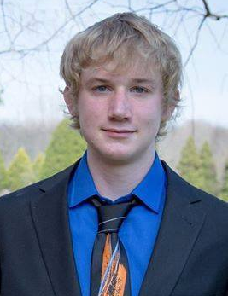
Joel Harkema comes to us from Hudsonville, Michigan. He went to Unity Christian High School, where he ran cross-country. Joel is a huge Nintendo fan. Recently, he's been spending his free time playing through the Shantae series. He doesn't have much time to himself however, as, in addition to being a full time student, he also works at a University dining hall. Joel is enrolled in the College of Engineering. He is, as of now, undecided as to what flavor of engineering he prefers. Despite advice to the contrary he insists on wearing socks with sandals whilst in public. I've told him he looks like a dork. He thinks he "looks beautiful".

Jim LeFebre by Jared Elenbaas
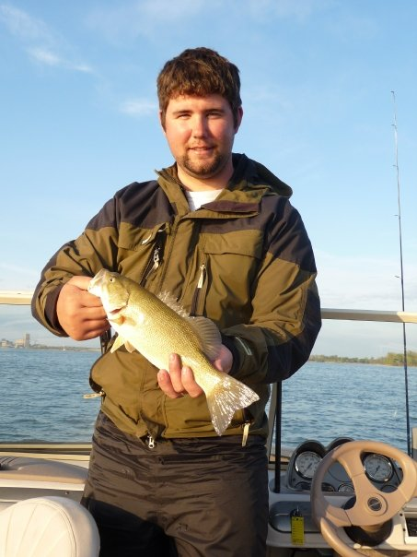
Jim is a visiting scholar from Ferris State University and is interested in nuclear medicine. He has great taste in beer, burgers, women, the outdoors, and anything else you can think of. Jim is a doer and has obtained the highest level of educational attainment in his family - and he’s only getting started. Despite all of his great achievements and talents, you will only find him boasting of one thing: his salvation through Jesus’ sacrifice. It is clear that this salvation is more important than anything else to Jim. It’s a shame that he’ll only be involved with PAK for this year, but his contribution to the Fraternity of Christ will never end.

Garrett Prost by Alex Harris

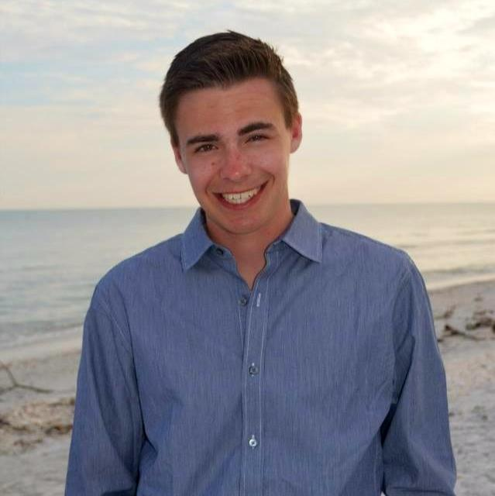
Garrett Prost is a sophomore studying Industrial Operations Engineering, with hopes of pursuing a career in analytics. He hails from the beautiful city of Rockford, MI and graduated from Rockford High School in 2014. It just so happens that I also call Rockford home and graduated from Rockford High School in 2009; this was clearly a big/little brother relationship that was destined to be. Garrett is a cool guy all around and has a number of hobbies, including playing guitar, long boarding, spending time at the beach, hanging out with friends and family, and playing sports of all kinds. He’s also extremely involved with SpringHill Camp, where he has worked as a camp counselor for the past several summers. Garrett has also shown that he is a person of strong character, and we’re all very grateful that he’s chosen to contribute to the community at Phi Alpha Kappa.

Will Perry by Nate Woznick
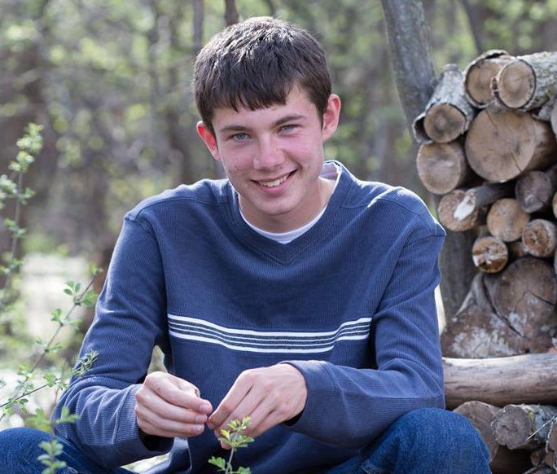
Will Perry is a freshman in the College of Engineering. He is currently looking towards majoring in Aerospace Engineering, and enjoys computer coding infinitely better than his big brother. Will is from Midland, where he attended Calvary Baptist Academy. At Calvary Baptist Will starred as the goalie for the soccer team, as well as the basketball team. Here at the University of Michigan, Will is a part of the Air Force ROTC program, which demonstrates his sense of purpose and leadership. We are looking forward to being blessed by his many skills and character traits in the future.

Jonathan Timma by Hayden Youngs

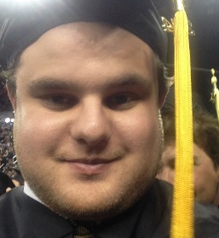
Jonathan Timma is no doubt the “crème of the crop” of this year’s pledge class. Jonathan is a master’s student studying Human-Computer Interaction, after graduating from the University of Michigan in the fall of 2014 with a Bachelor’s of Science in Information. Prior to college, Jonathan attended Warren De La Salle Collegiate High School and is a proud Pilot supporter. He is the oldest child in his family, and is a great big brother to his mentally handicapped sister.
Jonathan goes by his surname, “Timma”, and has patented Kirby’s bricking (Super Smash Brothers, N64), as he tends to use the move at a frequent rate. Timma is one of the biggest University of Michigan Football fans in the house, and he has high hopes for the remainder of the year. Unfortunately, he likes making bets with his Aunts and Uncles who happen to be MSU fans, which forced him into having to wear an ugly green shirt for a week. All in all, we are excited that Jonathan decided to pledge at the house, and we look forward to getting to know him more.

Michael Nykamp by Joe Sorenson
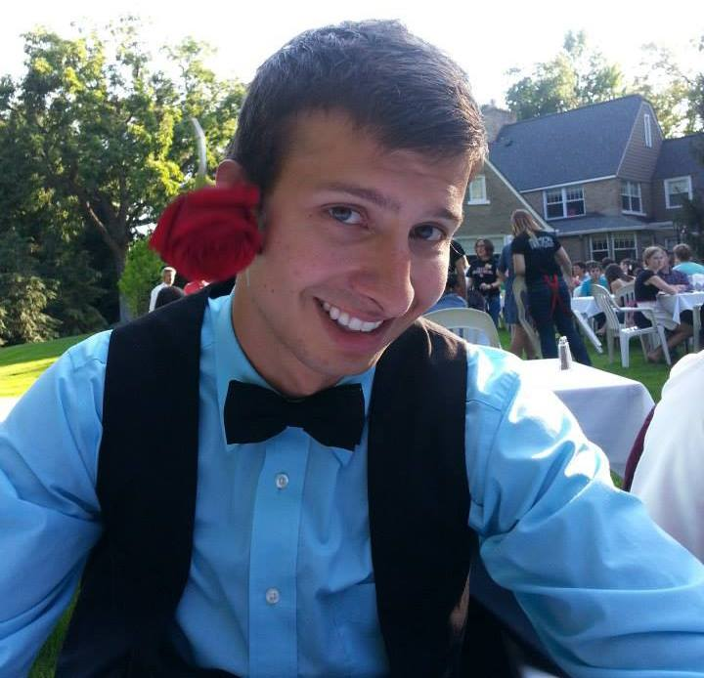
Michael Nykamp is a first-year dental student who has chosen to pledge at Phi Alpha Kappa this year. Like many others, Michael is from Grand Rapids, Michigan, where he attended Calvin College. He learned about the Fraternity from his father, who also attended the University of Michigan and who had good friends at Phi Alpha Kappa. Michael’s grandfather was also a member of the Fraternity.
Michael has many hobbies as well. He enjoys taking walks outside, by himself or with friends, and has been making good use of the Arboretum to do so. He also enjoys playing video games, which fits him in with the majority of members here. In addition, Michael has been trying his hand at creative writing. We hope we will grow to know Michael even more over the years he spends here.

Daniel Harris by Tate Mazer
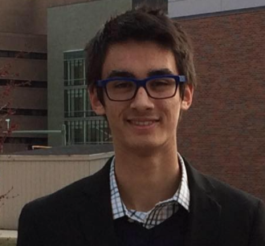
Daniel Harris is a freshman in-house pledge majoring in Microbiology. He was homeschooled in Midland, MI, and is brothers with Micah Harris, who is currently a lame-duck pledge. In high school, he liked to play basketball. He enjoys playing League of Legends and piano. He now plays piano for praise and worship. As for the future, he plans to apply for medical school.

Ryan Olthoff by John Swets

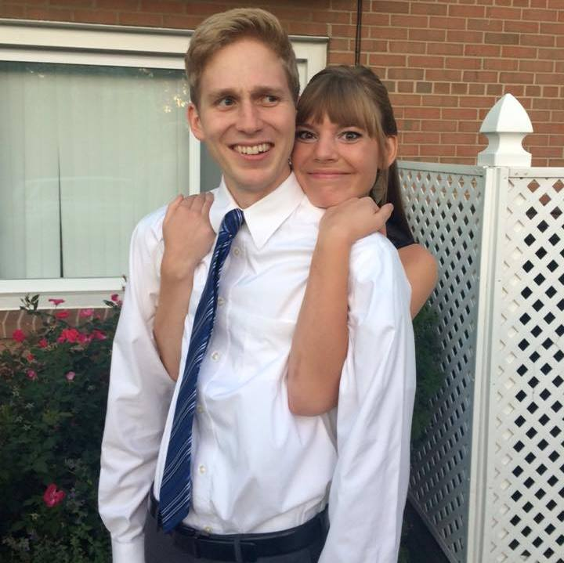
Ryan Olthoff graduated from Calvin College with a degree in business and sports management. Ryan is originally from Olney, Maryland where he attended Washington Christian Academy. The past few weeks have held large milestones for Ryan as he was recently accepted to the sports management Ph.D. program at the University of Michigan, which he will start in January of 2016. In addition, Ryan recently got engaged to his now fiancé, Lauren, who is a first year medical student at the University of Michigan Medical School.
In the intermediate semester between his undergrad at Calvin and starting his Ph.D. at the University of Michigan, Ryan has taken a job at Joyce Julius as a television marketing analyst. In his free time, Ryan enjoys spending time with and his fiancé and playing Halo and other videogames with his roommate, Michael.

Taylor Buist by Alari Maricq
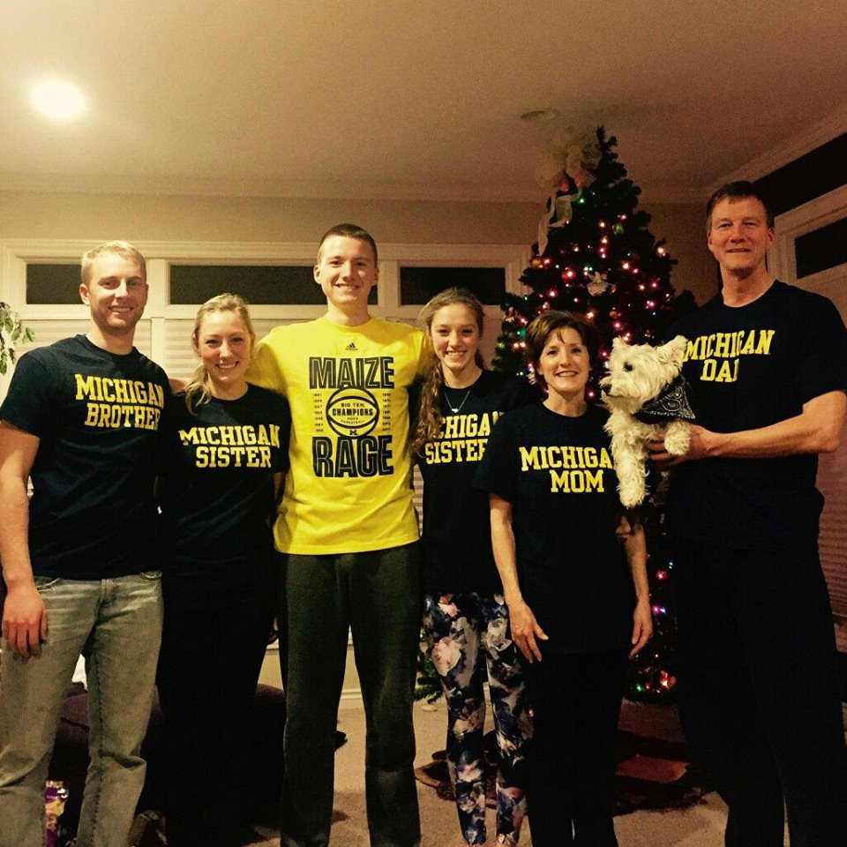
Taylor Buist, a sophomore in Computer Science, started pledging last winter. So, he is almost done with his pledgeship. Taylor is from Grand Rapids, Michigan, and graduated from South Christian High School. He enjoys playing intra-mural sports, Super Smash Brothers, and eating burgers. I'm sure Taylor will be a great addition to our fraternity.

Curt Silverthorn by Ryan Wawrzaszek

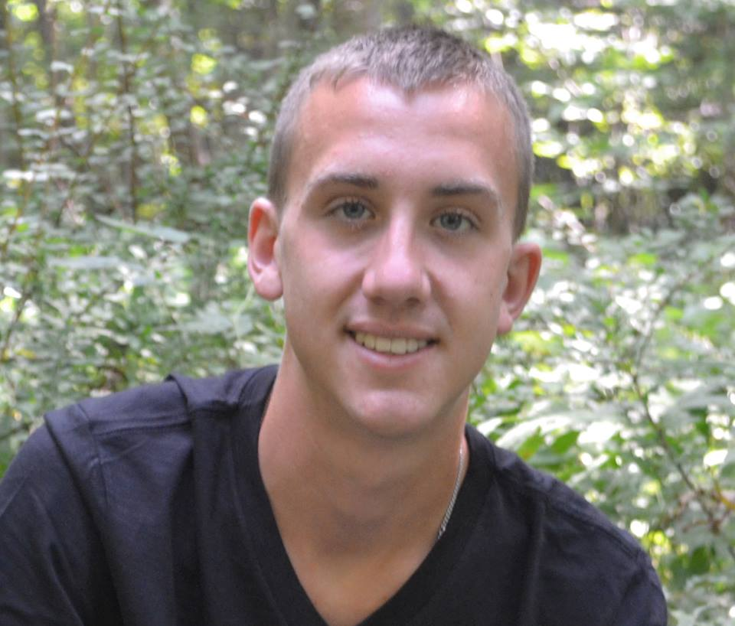
Curt Silverthorn is a sophomore studying Computer Engineering. He is originally from Yale, Michigan where he attended Yale High School before coming to the University of Michigan. Curt’s hobbies include reading, hunting, and playing sports. He enjoys travelling and spent six weeks in Spain this summer as part of the University’s study abroad program. Curt also raises pigs and won several awards at the St. Clair Country Fair this past summer!
Curt was an out-of-house pledge last winter, so it has been wonderful having him in the house this year and getting to know him even better. We are looking forward to welcoming him into active membership at the end of the semester.

Micah Harris by Lucas Barnes

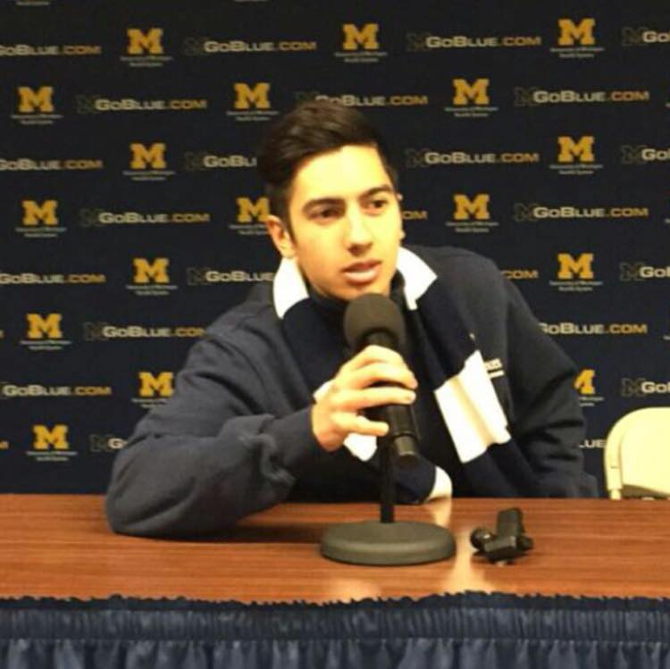
Micah Harris is a sophomore in the College of Kinesiology. As a movement science major, he has a very difficult workload, but makes sure to stay active as a member of the University of Michigan club running team known as M-Run. As a part of the team he travels all over the Midwest to race outdoor cross country, indoor, and outdoor track, and is training daily, logging as many as 60 miles running per week. Outside of running, he enjoys studying on the porch when the weather is nice, hanging out in the executive double, and waking up ridiculously early to go swimming at the gym. He also enjoys wearing weird hats. You won't find a better natured person than Micah. He is one of the friendliest people you will meet, and always has a smile on his face. It is without question that he is an excellent addition to the organization, and he will do wonderful things here.

The Active Members

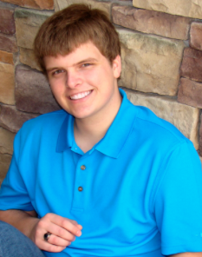 | Zack Felker  Historian  Sophomore  Physics, Astronomy | 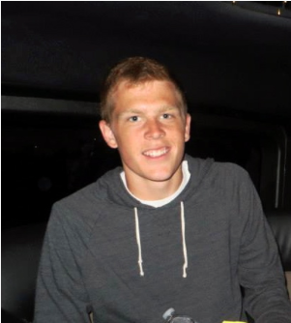 | Lucas Barnes  Steward  Junior  Naval Architecture and Marine Engineering
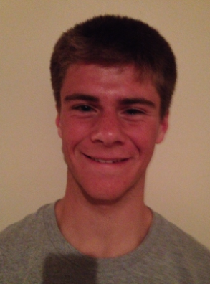 | Nate Woznick  Athletic Chairman,  Chaplain  Sophomore  Mechanical Engineering | 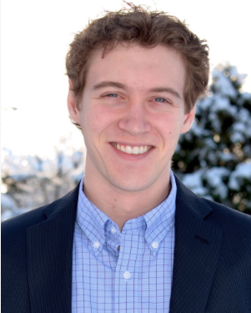 | Alex Harris  3rd year medical student  Medical School
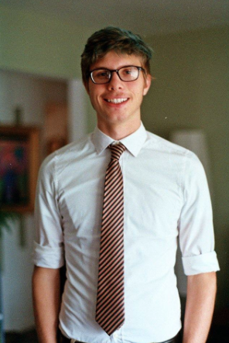 | Tate Mazer  Sergeant,  Webmaster  Sophomore  Computer Engineering | 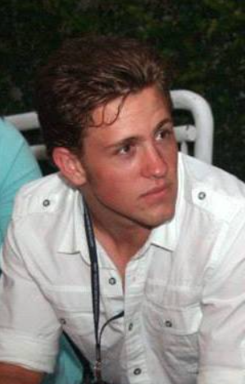 | Jared Elenbaas  Master’s Student  Physiology
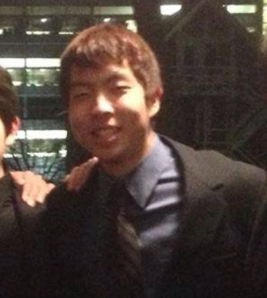 | Joe TenBroek  Social Chair  Junior  Mechanical Engineering | 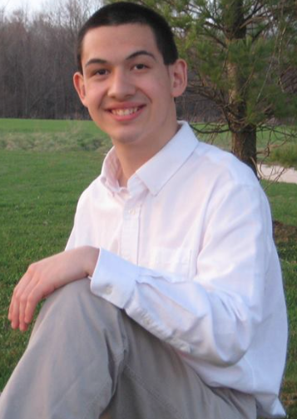 | Jacob Molewyk  Charity Chairman  Sophomore  Civil Engineering
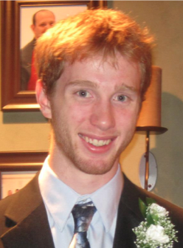 | Alari Maricq  Steward  Senior  Aerospace Engineering | 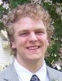 | Isaac Olson  Master’s Student  Aerospace Engineering
 | Joe Sorenson  Beastmaster  Junior  Computer Science | 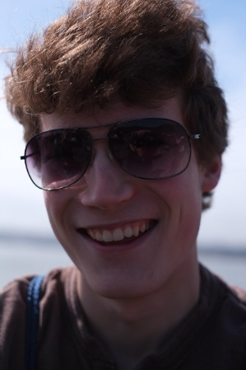 | Matt Rouhana  Pledge Chairman  Master’s Student  Industrial and Operations Engineering
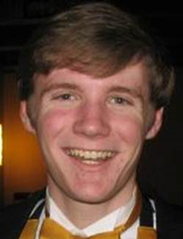 | Ryan Wawrzaszek  Business Manager  Master’s Student  Computer Science | 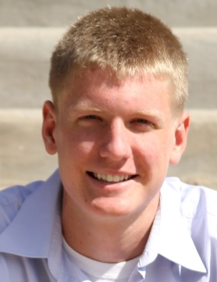 | John Swets  President  Senior  Chemical Engineering
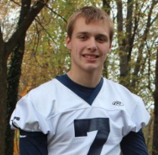 | Hayden Youngs  Vice President  Junior  Mechanical Engineering

