
Phi Alpha Kappa
Newsreel
Fall 2014 Issue

A tradition of Phi Alpha Kappa Christian Fraternity since 1934

Presidential Greetings

Dearest Alumni and Friends of Phi Alpha Kappa,

Warm greetings from the active chapter in Ann Arbor, where we have begun to feel the cold bite of winter and hear the crunch of leaves underfoot. The semester is in full swing and our members are busy studying for midterms and fervently looking forward to Thanksgiving break.

The fraternity is doing well this year, but we are again struggling a little with keeping our numbers up with only 14 active members. That being said, we are encouraged by the fact that our recruitment over the last year has manifested itself in a good-sized pledge class of eight. In the hopes of continuing to be a light at Michigan and in Ann Arbor, I ask that if you know of anyone who is looking for a place to live among Christian men at the University of Michigan, tell them about the great fraternity that is Phi Alpha Kappa. We hope that through this we can attract Christian men of character to join our brotherhood, and carry on the traditions of the Dutch House for years to come.

I would like to thank all of the alumni who were able to join us for Alumni Day this past weekend. It was great to be able to meet, converse, and reminisce with you about your time spent in Ann Arbor and at the fraternity. Phi Alpha Kappa is very blessed to have the prayers and support of such an outstanding alumni network. Special thanks go out to the Alumni Board for the time and effort that they constantly give the Dutch House. We truly appreciate your support, encouragement, and guidance.

Overall, things are going well at Phi Alpha Kappa. Although membership is a little down, our brotherhood is still strong. We ask that you continue to keep Phi Alpha Kappa and its members in your prayers, as we seek out Christ in our own lives, and strive to bring his love and mercy to the rest of the University of Michigan.

God bless you all,

John Swets
Active Chapter President
pres@phialphakappa.com

Table of Contents

In this Issue:

Presidential Greetings 1
Announcements 3
A Word about our Website 3
Officer Reports 4
Vice President Report 4
Business Manager Report 5
Sergeant-At-Arms Report 5
Steward Report 5
Social Chairman Report 5
Pledge Chairmen Report 6
Athletic Chairman Report 6
Chaplain Report 7
Meet the Pledges 8
Braden DeWeese by Matt Rouhana 8
Jacob Molewyk by Joe TenBroek 9
Jared Elenbaas by Dan Bosscher 9
Joel Smit by Ryan Wawrzaszek 10
Nate Woznick by Lucas Barnes 10
Tate Mazer by Domenic Kelly 10
Zack Felker by Joe Sorenson 11
The Active Members 12

Announcements

A Word about our Website

Please, visit our website! This is a great way to stay up to date on the current happenings and fraternity activities. It’s also a great tool for recruiting new members. Updates are coming soon.

If you know of any young men who might be interested in Phi Alpha Kappa, please share our website with them!

www.phialphakappa.com

.

Officer Reports

Vice President Report

Spring and summer recruiting resulted in eight new pledges for the fall of 2014. These include four freshmen, a junior transfer student, and three graduate students. Unfortunately, two of these pledges de-pledged, but our Festifall booth and word of mouth brought in two new out of house pledges: a freshman and a graduate student. Aside from the Festifall booth, we have purchased bus signs to increase our influence on campus. We also are hosting our annual Halloween party, which has the potential to produce prospective pledges. Finally, we have allowed prospective pledges to join our intramural softball team as a way to get to know some of the members.

Please continue to encourage anyone you know who is attending Michigan or will potentially be applying to Michigan to check us out. With 15 current actives it is crucial that we continue to have large pledge classes.

Lucas Barnes, Vice President
vp@phialphakappa.com

Business Manager Report

This is my second year as Business Manager at Phi Alpha Kappa, and the house is in good financial shape. We are two residents under capacity this semester, with 14 actives, 6 pledges and 9 boarders living in the house, and 2 pledges out of house. Kitchen and Operations budgets are consistent with past years, and the social budget is being used efficiently, so we should remain in good financial standing all year. By cutting down on unnecessary spending and focusing on repairs and improvements to the house, we will improve life in the house while maintaining a reasonable budget.

Ryan Wawrzaszek, Business Manager
business@phialphakappa.com

Sergeant-At-Arms Report

This summer and fall the house has received a number of important renovations. During the summer the carpet in the halls, stairs, and several rooms was replaced. Additionally, a new liner was installed in the chimney, bringing our house back into compliance with fire code. Finally, a section of floor in the second floor bathroom, which was removed last fall so we could repair the radiator, was finally replaced this summer. The alumni board graciously funded all of these projects.
This fall started out with a few days of heavy rain and the unpleasant surprise that we had flooding problems in the basement in both the kitchen and workroom. The flooding in the kitchen was due to the storm drain in the kitchen fire escape backing up. The blockage was promptly cleared and a new drain cover was installed to prevent future blockages. The flooding in the workroom took longer to find the cause of, but during work day some members of the house discovered that a downspout extension near the west turret was backed up. The blocked pipe was replaced, and a new connector was placed between the downspout and the extension to provide a better seal. Speaking of workday, other things that the active chapter was able to accomplish during workday include cleaning the gutters, steam cleaning the Great Room carpets, and replacing some of the window ropes in the dining room and Great Room.

Dan Bosscher, Sergeant-at-Arms
sergeant@phialphakappa.com

Steward Report

Greetings brothers. I am pleased to announce that Amy, our cook, has returned for her 20th year of service to Phi Alpha Kappa, and continues to provide us with delicious food. The kitchen has been in such a state of cleanliness, that Amy herself has voiced her thanks to that regard. And I am pleased to say that everyone in the house has been doing their part to keep the dining room and kitchen a clean and inviting place to gather and enjoy meals.

Alari Maricq, Steward
steward@phialphakappa.com

Social Chairman Report

So far, the brothers of PAK have been extremely social, having been seen playing occasional games of Super Smash Bros, going to occasional football games, getting acquainted with the pledges, and getting involved with many groups around campus. Although our football team has suffered a number of devastating losses, the brothers and pledges alike stay proud and supportive and continue to bleed maize and blue! Our first social event, a Tigers game, was still fun despite few people going. For the future, we plan to have a number of events towards strengthening the brotherly bonds between brothers and pledges, such as Whirlyball, Skyzone, a super smash bros tournament, and much more. A big change this year, the annual Phi Alpha Kappa Halloween Party is being co-hosted with Sigma Alpha Omega, a Christian sorority formed this fall semester, so we can expect a huge turnout! As the year progresses, we hope to stay connected with Sigma Alpha Omega and that they continue to grow both in faith and in size as well. Overall, we can only expect good things this coming school year.

Joe TenBroek, Social Chairman
social@phialphakappa.com

Pledge Chairmen Report

We have been blessed with eight pledges this semester, six of which are living in the house. We have both undergraduates and graduate students, and their fields of study are very diverse. They have so far blended very well into the house and we can't wait to see them continue down the path to active membership.
We’ve had a great start to the semester, and we’re excited to see how the rest of the year unfolds. We have a lot planned, and we really hope that we’ll be able to help the pledges bond with each other and with the active chapter. Thank you for all your support of this great Fraternity as we continue to provide a great place for Christian men to live and grow.

Andrew Dykstra & Alex Harris
Pledge Chairmen

Athletic Chairman Report

Intramural sports are a great way for both members and pledges alike to bond and get to know each other better. This year we have competed in softball, and are set to begin playing flag football and broomball. Later in the year we will be competing in volleyball, wallyball, and potentially basketball.
While initial interest in playing softball was low, after our first game many of us found out that it was much more fun than expected. It took a few games, but we eventually began to bond as a team and start coming together to make plays. We ended the regular season with a record of 2-1, but lost in the first round of the playoffs to a very loaded roster from another fraternity. Although we were eliminated from the playoffs, we averaged 14.33 runs per game, which is well above average.
Much of our success in softball can be credited to our pledge class of 2014, which brings a lot of athletic background. We look forward to seeing even more of their athleticism in our upcoming flag football and broomball seasons.

Lucas Barnes, Athletic Chairman
athletic@phialphakappa.com

Chaplain Report

The men of Phi Alpha Kappa have started the academic year eager to grow as a community in Christ. To achieve this, we have continued several traditions that have helped past members enrich their faith. We are holding weekly Bible study in the Great Room, being led by the esteemed Matt Ackerman, the current pastor of Campus Chapel. In the first half of the term, we have been doing something a little different by watching the “For the Life of the World” video series. Each week we watch an episode and engage in great discussion. Actives, pledges, and boarders all attend Bible study, and every week proves to be a great session.
In addition to Bible study, the house also has a weekly half hour of praise and worship, held on Wednesday evenings in the Pool Room. We have several guitar players and even a drummer that help to provide music for our worship. Each session is a constant reminder of the great privilege we possess in living together as Brothers in Christ.
In addition to these weekly events, it is my hope that in the coming semester, the fraternity will take a weekend retreat, where we shall seek to better understand our relationships with each other, and our own personal relationships with Jesus.

Matt Rouhana
Chaplain

Meet the Pledges

These articles are written by big brothers about their little brothers.

Braden DeWeese by Matt Rouhana

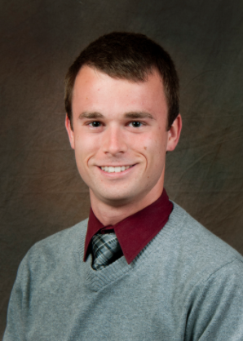
Braden DeWeese is no doubt the finest of our in-house pledges this year. Braden is a master’s student studying Biomedical Engineering. He completed his undergraduate degree at Michigan as well, in the field of Cellular and Molecular Biology. Prior to college, Braden attended Marshall High School, and hails from Marshall, Michigan.
Braden has often been described as “one heck of a swell guy” [citation needed]. He is a fan of sport, including soccer and softball. He’s also quite musical, playing the violin and often lending his awe-inspiring tenor voice to praise and worship. His other activities include dancing and singing while doing his house job and having cuddle puddles with his roommates, Hayden and Nate.

Hayden Youngs by John Swets

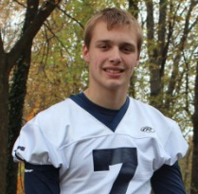
Hayden Youngs is a junior pledging at Phi Alpha Kappa this year. Hayden is originally from Byron Center and is the oldest in his family with three younger brothers and one younger sister. Hayden attended South Christian High School where he played tennis, baseball, and basketball in addition to being the quarterback for the football team. After high school, Hayden was a student at Grand Rapids Community College for two years before transferring to the University of Michigan to study mechanical engineering.
So far, his favorite class at Michigan is Dynamics and Vibrations but he is also currently taking Thermodynamics and Statics. Outside of school, Hayden enjoys being a part of a bible study group with his church and goofing off with his two roommates, Nate Woznick and Braden DeWeese.

Jacob Molewyk by Joe TenBroek
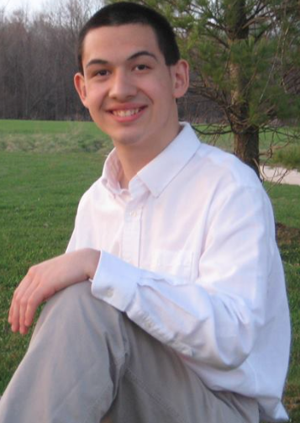
Jacob Molewyk is a freshman in-house pledge this year, looking to major in Civil Engineering. Before coming to this great university, he lived in the Chicago area until he was 15, eventually moving to Grand Rapids, MI. As he was homeschooled, he looked to progress his education further by taking classes at Grand Rapids Community College, some of which he took with another in-house pledge Hayden Youngs. While at GRCC, he started up the ethnically diverse Melting Pot Study Group. In his free time, he enjoys looking up current events, talking with friends, reading, thinking of cool business ideas, or policies he’d implement as a politician. After receiving his bachelor’s degree, he plans to get a Masters degree in Civil Engineering and an M.B.A. Outside of the house, he is involved in the Chinese Student Association, Taiwanese Student Association, Students for Life, New Life, and Christians on Campus. In the future, he hopes to be the president of Phi Alpha Kappa, perhaps as a senior. Overall, he’s an excellent addition to the house and we can expect great things from him in the future.

Jared Elenbaas by Dan Bosscher
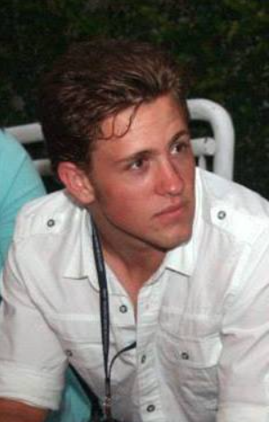
Jared Elenbaas is a grad student working towards a Masters of Physiology. He did his undergraduate work at Michigan State University where he studied biochemistry and molecular biology His current program is a one-year program, after which he hopes to move on to medical school to pursue an MD PhD. On top of course work, Jared also has a research position here at Michigan, where he studies liver damage.
Jared grew up on the west side of the state in the Grand Rapids area, where he attended Freedom Baptist High School and Hudsonville Public High School. He has three siblings including an older brother, and a younger brother and sister. In his free time Jared enjoys weight lifting, fur trapping, and bow hunting.

Joel Smit by Ryan Wawrzaszek
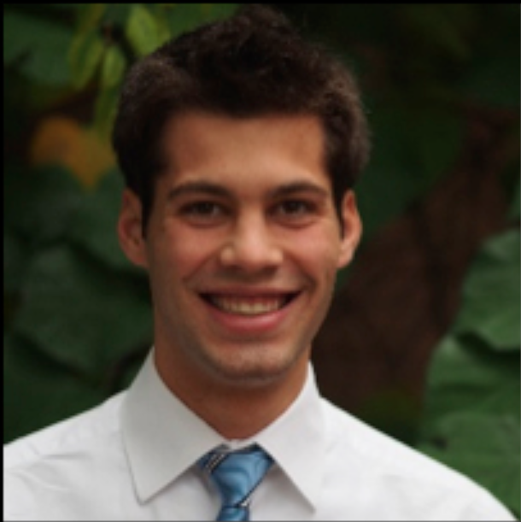
Joel Smit is a graduate student at the University of Michigan studying Structural Engineering who is pledging out-of-house this year. He is a recent graduate of Calvin College where he majored in Civil Engineering with a minor in Architecture.
Before Calvin, Joel attended Northpointe Christian High School, where he played football and was a captain on the baseball team. We are very glad to have Joel as a pledge brother and are looking forward to getting to know him better over the coming months.

Nate Woznick by Lucas Barnes

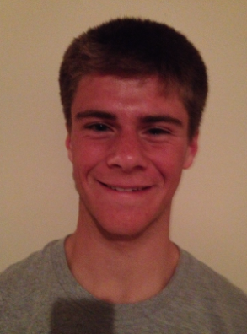
Nate Woznick is a freshman in the college of engineering. He is currently undecided on which type of engineering he will be pursuing. Nate is from Rockford, Michigan, and graduated from Rockford High School class of 2014. At Rockford he was a varsity athlete in track and basketball. He enjoys playing pick-up sports of any kind, and is known for never wearing a shirt around the house, showing off his glorious muscles. Nate is an exceptional physics student, and enjoys studying RC circuits and magnetism. In his free time, Nate enjoys playing basketball at the gym, and competing for intramural championships with the house teams. He will be a key addition to our football team. He will be showcasing his track and field speed and newly purchased receiving gloves as a wide receiver and punt returner.

Tate Mazer by Domenic Kelly

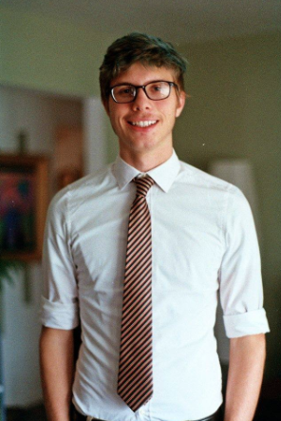
Tate Mazer is a freshman pledge at the University of Michigan. He is from Kalamazoo, graduating from Potage Central in 2014. Tate is in the College of Engineering, with a planned major in Computer Engineering. In high school, he ran on the track and cross-country teams, and had the fastest 200m time on the team. He also participated in a number of computer programming competitions.
In his free time, Tate enjoys watching movies and playing video games. He is a fan of thrillers (though not horror movies), movies that keep him on the edge of his seat – Super 8 is his favorite movie. If he had more time, he would enjoy drumming – something he used to do for his youth group in high school.

Zack Felker by Joe Sorenson
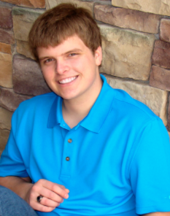
Zack Felker is a new pledge at Phi Alpha Kappa. He came here from Rockford, Michigan, and will be living out of house. He is a freshman at the University of Michigan and is part of the college of Literature, Science and the Arts. He has not decided on a major, but is leaning towards Mathematics.
At the University, he is part of the Student Astronomical Society. His other hobbies involve fencing and keeping bees. He also enjoys playing videogames, especially the Civilization franchise.

The Active Members

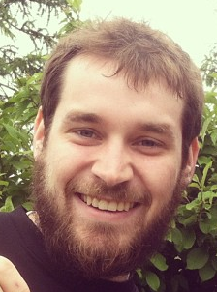 | Daniel Bosscher  Sergeant-At-Arms  Master’s Student  Computer Science | 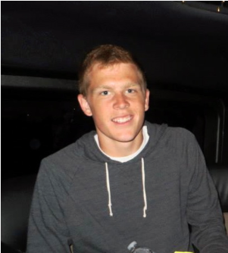 | Lucas Barnes  Vice President,  Athletic Chair  Sophomore  Naval Architecture and Marine Engineering
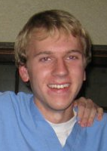 | Andrew Dykstra  Pledge Chair  Senior  Environmental Restoration | 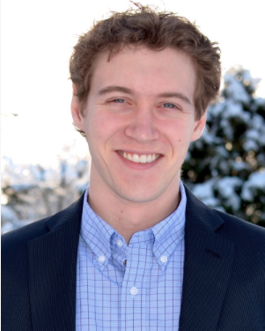 | Alex Harris  Pledge Chair  2nd year medical student  Medical School
 | Nathan Falstad  2nd year MBA  Master of Business Administration | 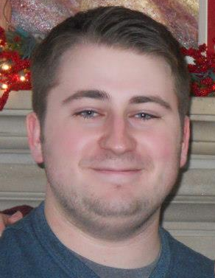 | Domenic Kelly  Secretary, Webmaster  Senior  Computer Science and Mathematics
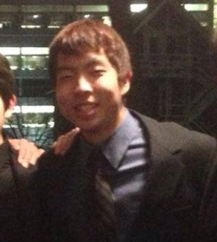 | Joe TenBroek  Social Chair  Sophomore  Mechanical Engineering |  | Joe Kropiewnicki  Senior  Actuarial Math and Economics
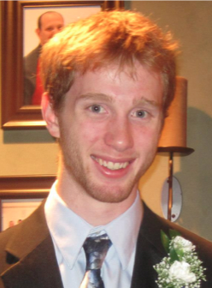 | Alari Maricq  Steward  Junior  Aerospace Engineering | 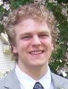 | Isaac Olson  Senior  Aerospace Engineering
 | Joe Sorenson  Sophomore  Undecided |  | Matt Rouhana  Chaplain  Senior  Industrial and Operations Engineering
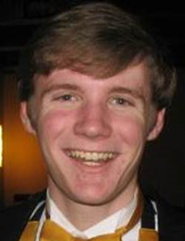 | Ryan Wawrzaszek  Business Manager  Senior  Computer Science and CMDB | 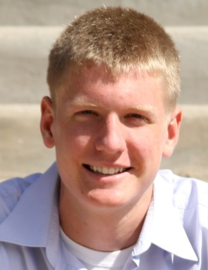 | John Swets  President  Junior  Chemical Engineering

