
Phi Alpha Kappa
Newsreel
Fall 2013 Issue

A tradition of Phi Alpha Kappa Christian Fraternity since 1934

Presidential Greetings

Dearest Alumni and Friends of Phi Alpha Kappa,

Greetings and salutations from the Active Chapter! The school year is now well under way at Phi Alpha Kappa, and the members have been busy studying for exams and are starting to eagerly look forward Thanksgiving break.

The fraternity is in good form at this point in the year. Our membership is not as high as it has been in past years, with 17 members and 5 pledges. However, we are not deterred in our efforts to recruit new pledges and carry out the mission of the fraternity. That being said, I ask that if you know of anyone who is looking for a place to live among Christian men at the U of M, tell them about the great fraternity that is Phi Alpha Kappa. We hope that through this we can attract Christian men of character to join our brotherhood, and carry on the traditions of the Dutch House for years to come.

I would like to thank all of the alumni who were able to join us for Alumni Day a few weeks ago. Phi Alpha Kappa is very blessed to have the prayers and support of such an outstanding alumni network. Special thanks go out to the Alumni Board for the time and effort that they constantly give to the Dutch House. We truly appreciate your help and encouragement.

Overall, things are going well at Phi Alpha Kappa. Although membership is a little down, brotherhood is still strong. We ask that you continue to keep Phi Alpha Kappa and its members in your prayers, as we seek out Christ in our own lives, and strive to bring his love and mercy to the rest of the University of Michigan.

God bless you all,

Matt Rouhana
Active Chapter President
pres@phialphakappa.com

Table of Contents

In this Issue:

Presidential Greetings 1
Announcements 3
A Word about our Website 3
Officer Reports 4
Vice President Report 4
Business Manager Report 5
Sergeant-At-Arms Report 5
Steward Report 5
Social Chairman Report 6
Pledge Chairmen Report 6
Athletic Chairman Report 7
Chaplain Report 7
Meet the Pledges 8
Lucas Barnes by Joe Kropiewnicki 8
Alex Harris by Ryan Wawrzaszek 8
Alari Maricq by Matt Rouhana 9
Joseph Sorenson by John Swets 9
Joe TenBroek by Colin Driscoll 10
The Active Members 11

Announcements

A Word about our Website

Please, visit our website! This is a great way to stay up to date on the current happenings and fraternity activities. It’s also a great tool for recruiting new members. Updates are coming soon.

If you know of any young men who might be interested in Phi Alpha Kappa, please share our website with them!

www.phialphakappa.com

.

Officer Reports

Vice President Report

Summer recruiting resulted in seven new pledges – A graduate student from Calvin, a medical student from Calvin, two in-house freshmen, one in-house sophomore, and two out-of-house freshmen. It is encouraging that almost all of these pledges plan to be here for three or more years. Unfortunately, we had two de-pledge in the first month, and another very recently, but we did manage to pick up another out-of-house freshman. As of right now, we have five pledges. We are trying to increase our influence on campus through flyers and through really pushing the Halloween party this year (it is convenient when the Vice President is also the Social Chair).

Counting the three de-pledges, we have nine boarders in the house. This is partly due to losing thirteen members this past spring to graduation. A larger-than-normal pledge class for 2014-2015 is crucial to keep our membership numbers high. Twelve to fifteen pledges would be ideal. We hope that through standard word-of-mouth, the Halloween Party, and other advertising around campus we can achieve this target.

Joe Kropiewnicki, Vice President
vp@phialphakappa.com

Business Manager Report

This is my first year as Business Manager at Phi Alpha Kappa. The new school year has started, and Phi Alpha Kappa is in good financial shape. We are one resident under capacity this year, with 17 actives, 4 pledges and 9 boarders living in the house, so we should remain in good financial standing all year. By cutting down on unnecessary spending and focusing on repairs and improvements to the house, we will improve life in the house while maintaining a reasonable budget.

Ryan Wawrzaszek, Business Manager
business@phialphakappa.com

Sergeant-At-Arms Report

I am pleased to see a strong interest in the up keeping of Phi Alpha Kappa. The house remains in great condition due to the active roles of the members. No major maintenance has been necessary throughout the semester. However, one necessary action is to fix the water damage in the mail room. Work day is planned for October 26 where only minor maintenance will be performed. A house inspection was performed on October 4 and almost everything was passed. The remaining items will be closed as a work day project. I look forward to a great year at the house.

Kevin Egedy, Sergeant
sergeant@phialphakappa.com

Steward Report

Ahoy fellow fraternal friends from ΦAK. We now find ourselves faced with a freshly fallen year, and the fraternity dining room continues to function as a fortress of fellowship and fratitude amongst members of the fraternity. Our chef, Amy, and I have remained the faithful faculty of our fine kitchen, providing fraternal affiliates with a variety of first-rate feasts, for every function from Fridays to Fiestas.

With ten less than forty fellows found under one roof, (though far fewer are affiliates of the organization), it would be fallacious to figure that one would find our kitchen in a frightening form. In fact, as one might foresee, our kitchen is frequently found in fantastic shape, due to the fabulous efforts of our combined forces.

As the year is still fresh, I still have a flowering of unsullied developments and reforms planned for the feasting quarters. I am forever and for all time seeking new ideas to manifest into a physical form for our brotherhood to enjoy. I am fervent to ascertain what this fraternal phylogeny is fit to achieve in the final months following the first two of this Fall Semester.

Joel Koper, Steward
steward@phialphakappa.com

Social Chairman Report

We have had a fun semester so far. We took a trip to a Tigers game earlier in September and have had fun tailgating and watching away football games. Upcoming we have our annual Whirlyball game, which is always a favorite. The Halloween party is approaching as well. This year we are trying to restore the Halloween party to its former glory. We will be advertising heavily around campus, especially to Christian groups such as New Life and CRU. The goal is to really put in some effort and make the party successful and well attended in order to attract new pledges to the house.

Further down the semester we will be chucking dodge balls at each other while jumping on trampolines at SkyZone Trampoline Park. We plan to do that near finals in order to vent some stress and release some endorphins. Various smaller events will be mixed in throughout the semester, until we conclude with our Christmas party. Hopefully more of us can get dates this year (last year was pretty pathetic).

Joe Kropiewnicki, Social Chairman
social@phialphakappa.com

Pledge Chairmen Report

Dearest Alumni, we have been blessed with
five pledges this semester, three of which are living in the house. They are a mixture of undergraduates and graduate students with quite a few engineering majors, a medical student, and some LSA degrees. It seems that so far the new pledges are fitting very well into the house and we can't wait to see them continue down the path to active membership.

They are doing a wonderful job playing plenty of fetch with the house dog, Riley, and making sure that the house is free of dust. Our annual Pledges vs. Actives football game was on Oct. 19th, and as always, the demonstrated the peak of athleticism that is the Active Chapter. We also enjoyed getting some of our Alumni out to the game to officiate.

We’ve had a great start to the semester, and the outlook for the rest of the semester and year is very good. We have a lot planned, and really hope to strengthen our relationship with this year’s pledges. Thank you for all your support of this great Fraternity as we continue to provide a great place for Christian men to live and become a part of.

Andrew Dykstra & Kevin Egedy
Pledge Chairmen

Athletic Chairman Report

The intramural sports teams organized by the fraternity provide great bonding experiences for everyone in the house as both members and pledges can come together and work together as team. Over the course of the year we play a number of different sports ranging from soccer to flag football to basketball and volleyball.

So far this year we have only had the chance to play intramural soccer as the intramural season of the year is just beginning. Despite a heartbreaking loss in the quarterfinals of the playoffs, we have managed to finish the season with a 3-2 record which is amazing considering that we managed to play the entire season without scoring a single goal. We are, however, redoubling our efforts as we look forward to the flag football and broomball seasons that are swiftly approaching.

John Swets, Athletic Chairman
athletic@phialphakappa.com

Chaplain Report

This semester the house is following along with Calvin College's Exodus Bible study under the direction of Matt Ackerman from the Campus Chapel. Matt meets with a group of guys from the house in the Great Room every Tuesday after dinner. Most weeks, around seven or eight guys from the house are able make it to Bible study, including boarders living in the house and out of house pledges.

In addition to Bible study, the house also has a weekly half hour praise and worship. Praise and worship is generally on Wednesdays at 10:30 in the pool room. Junior Dominic Kelly helps every week to lead praise and worship on his guitar, and we usually have one other guitar player and sometimes a drum player. Attendance for praise and worship is usually around five or six people.

As far as charity events for the semester, on Saturday, November 2 members from the house will head over to the Campus Chapel to help with their fall work day. Among other tasks, Matt has told me that we will be working on cleaning up the outside of the Chapel to keep the area looking nice.

Daniel Bosscher
Chaplain

Meet the Pledges

These articles are written by big brothers about their little brothers.

Lucas Barnes by Joe Kropiewnicki

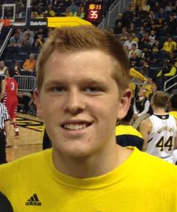
Lucas Barnes is a freshman out-of-house pledge from Caledonia. In high school, he ran cross-country and track and was on the swim team. He enjoys playing all sports, which is good because we need some fresh talent on the IM teams. Being a swimmer and a runner, Lucas enjoys triathlons. He is a member of the triathlon club at U of M.
Lucas is in the engineering school, but is undecided on which branch of engineering to pursue. He currently works for the U of M Department of Physiology and Molecular Biology as a lab assistant, which is a pretty impressive position for a freshman. We are very excited that Lucas has chosen to pledge at the house. It will be nice to get to know him throughout the year.

Alex Harris by Ryan Wawrzaszek
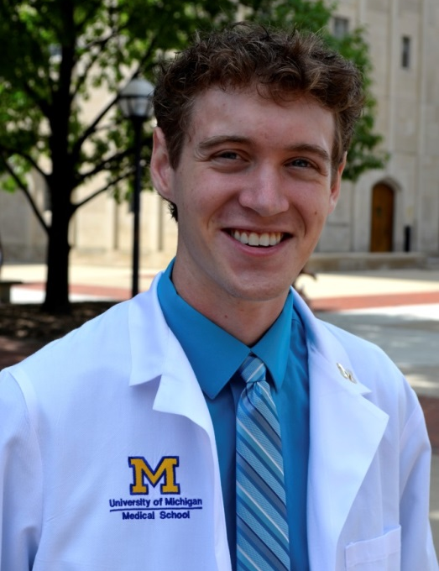
Alex Harris is a first-year medical student at the University of Michigan. He is from Rockford, MI, and graduated from Rockford High School in 2009. Alex graduated from Calvin College in 2013. After finishing medical school, he hopes to pursue a career in surgery. Alex’s hobbies include playing guitar, playing tennis, making balloon animals, playing video games and spending time with friends. We are very glad to have Alex living in the house this year and are looking forward to getting to know him better.

Alari Maricq by Matt Rouhana

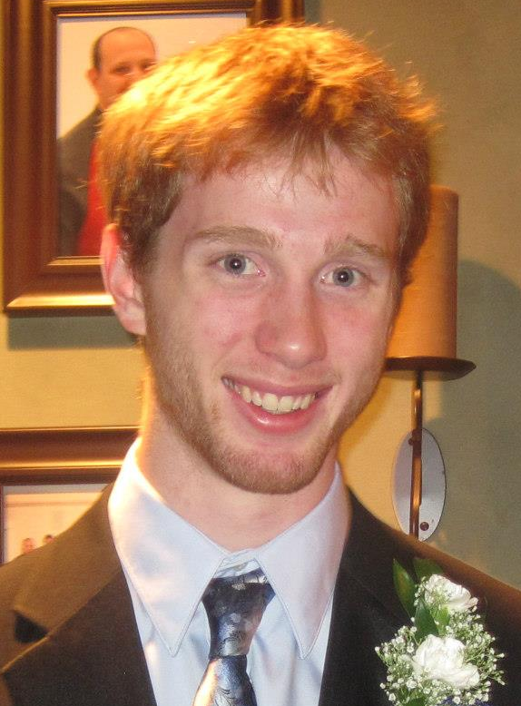
Alari Maricq is one of our in-house pledges this year, a sophomore from Gross Isle, Michigan. Prior to the University of Michigan, Alari attended Summit Academy. Now that he is at UM, he’s majoring in Aerospace Engineering. Alari is the younger brother of a Phi Alpha Kappa alumnus, Kalev Maricq.
Alari is quite an active pledge. He loves many sports, including volleyball, running, biking, and especially downhill skiing. He’s also quite musical, playing clarinet, cello, saxophone, and piano. He is a part of the UM Campus Band, in which he plays clarinet. Alari also takes his faith seriously, and is very involved with New Life church on campus. His other activities include playing many video games and eating an excessively large number of cookies.

Joseph Sorenson by John Swets


Joseph Sorenson is an out of house freshman pledge at Phi Alpha Kappa this year. He is from Ann Arbor, having lived here for most of his life since his birth in April of 1995. Joe went to Father Gabriel Richard High School before attending the University of Michigan. In high school, Joe ran on the cross country and track teams but his passion was in the drama club. As a member of the drama club for three years, Joe assisted in the production of several school plays. Joe, like many freshmen, is undecided in the major he will pursue at the University of Michigan.
Joe enjoys reading in his spare time, especially science fiction and fantasy. Despite being an out of house pledge, Joe spends a fair amount of time at the fraternity and has been an avid participant in our Intramural Soccer team so far this year. Joe also spends some of his free time at home helping his parents care for his thirteen siblings.

Joe TenBroek by Colin Driscoll

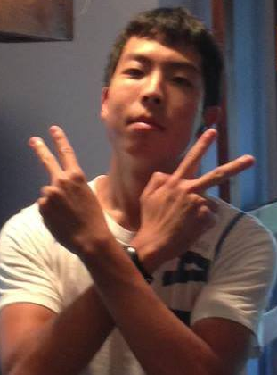
Joe Tenbroek is a pledge living at Phi Alpha Kappa. He is from Ann Arbor and attended Skyline high school. Currently, he is a freshman at the University of Michigan studying to be a chemical engineer. In his free time Joe enjoys playing basketball, running, and composing dope raps.

The Active Members

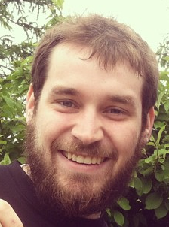 | Daniel Bosscher  Chaplain  Master’s Student  Computer Science | 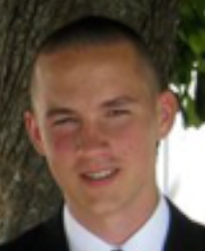 | Colin Driscoll  Senior  Mathematics
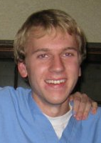 | Andrew Dykstra  Secretary, Pledge Chair  Senior  Industrial and Operations Engineering | 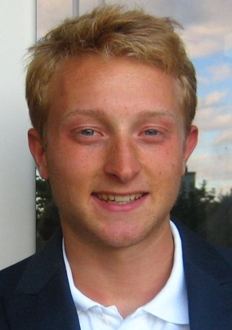 | Kevin Egedy  Sergeant, Pledge Chair  Senior  Electrical Engineering
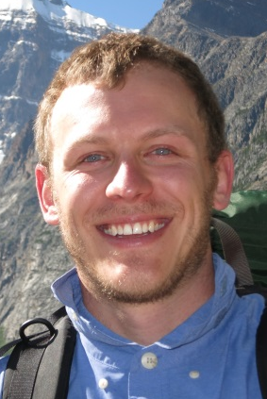 | Nathan Falstad  1st year MBA  Master of Business Administration | 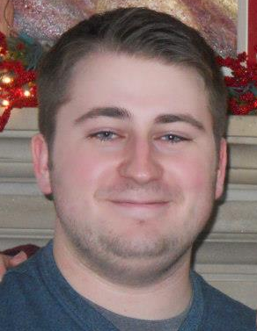 | Domenic Kelly  Webmaster  Junior  Computer Science and Mathematics
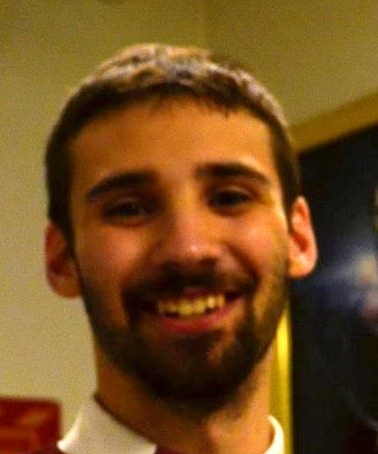 | Joel Koper  Steward  Senior  Biochemistry | 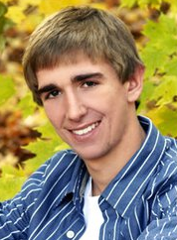 | Joe Kropiewnicki  VP and Social Chair  Junior  Actuarial Math and Economics
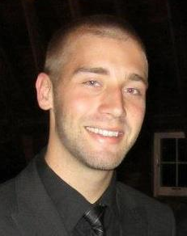 | Brian Mejeur  Master’s Student  Aerospace Engineering | 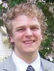 | Isaac Olson  Senior  Aerospace Engineering
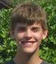 | John Pederson  Undecided | 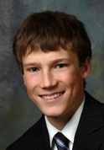 | Matt Rouhana  President  Senior  Industrial and Operations Engineering
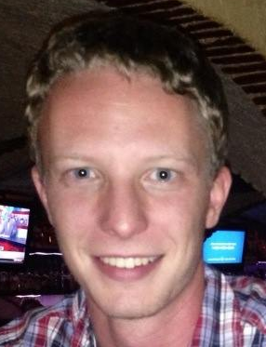 | Lukas Vander Linden  Master’s Student  Environmental Engineering | 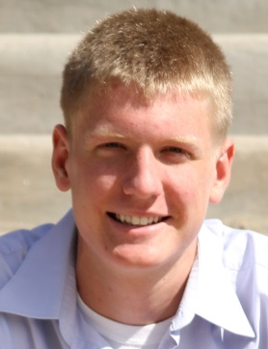 | John Swets  Athletic Chair  Sophomore  Chemical Engineering
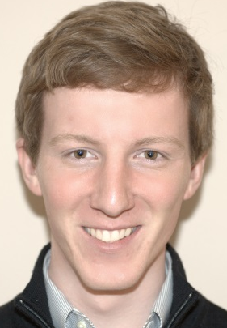 | Mark Vander Roest  Junior  Biomedical Engineering | 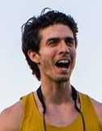 | Jade Watts  Super Senior  Industrial and Operations Engineering
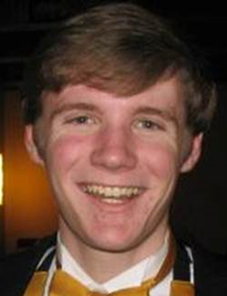 | Ryan Wawrzaszek  Business Manager  Senior  Computer Science and CMDB

